|  |
| --- |
| University of Houston - Downtown |
| Deposition Scheduling |
| Software Engineering |

|  |
| --- |
| Douglas Gillory  Colem Burgess  Shawn Varnado  Phillip Sanders  Aziz Omar  Francis Vandinh  May 10, 2021 |

Contents

Introduction 4

Security Level* 4

Functional Requirements 4

Functional Requirements 4

Non-functional Requirements 5

User Interface Requirements 6

Use Cases 8

Login User 8

Register User 8

Register Preferences 9

Invoice Firm 9

Request assistance 9

Schedule Deposition (Firm) 10

Edit Scheduled Deposition (Staff) 11

Search for Staff 12

Search for Offices 12

Search for Firms 12

Search for Conference Room 13

Search for Depositions 13

Class Diagram 14

Class Attributes 15

State chart 16

Use-case Realization 17

Login 17

Client Registration 17

Firm Scheduled Deposition 17

Search for Conference Room 18

Search for Deposition 19

Search for Firms 19

Search for Offices 20

Search for Staff 21

Request Assistance 21

Invoice Firm 22

Register Preferences 23

Detailed Design 24

Invoice Report Class 24

Schedule Report Class 24

Deposition Report Class 24

Billing Class 24

Invoice Class 26

User Data Class 27

Communication Class 29

Deposition Class 30

Database Class 31

Schedule Class 35

Search Class 36

Request Class 38

Registration Class 39

User Interface Class 42

Implementation 47

Test Cases and Results 48

User Documentation 49

# Introduction

The Deposition Scheduling Software is a database-built system that will hold and maintain data for a deposition scheduling company. The system will allow employees of the company to view, edit, update, and cancel all scheduled depositions and conference rooms, so they can schedule accordingly. The company’s clients (firms) will also be able to use the database to view the firm’s previous and upcoming depositions as well as schedule conference rooms through their member portal.

There are four different levels of security:

### Security Level*

1. Administrator – highest level access privilege, access to Configuration Tasks and all lower security level tasks
2. Manager – access to initiation and override commands and all lower security level tasks
3. Staff – access to all data entry tasks and lower security level tasks
4. Firms– access to data entry tasks restricted to specific firm account

Firms can also book a deposition immediately at the sight if a conference room is available simply by using the touchscreen interface located outside each conference room. This helps not only the clients to schedule emergency Depositions however frees up staff members in order to ensure all local and federal laws are followed.

# Functional Requirements

## Functional Requirements

1. The system shall be able to perform searches on staff, office locations, firms, conference rooms, depositions, and calendars.
2. The system shall be able to maintain data on staff, office locations, firms, conference rooms, depositions, and calendars.
3. The system shall track each conference room availability, all firms scheduled depositions and the location each are completed.
4. The system shall be able to report on staff, office locations, firms, conference rooms, depositions, and firms’ calendar.
5. The system shall be able to invoice each firm monthly.
6. The system shall be able to accept payment from invoices and email receipt.
7. The system shall be able to register new users, staff, firms, and clients, in addition to recording the conference room number and location.
8. The system shall be able to accommodate all accessibility needs as required by federal, state, and local laws.
9. The system shall be able to schedule depositions based on availability, date, time, and number of people included.
10. Based on the type of deposition, the system shall be able to suggest a timeframe when scheduling depositions however allowing the user to adjust the time.

## Non-functional Requirements

Figure Non-Functional Requirement Flow Diagram

*Performance*

* The system shall be able to support 1000 simultaneous users.
* Response time should be less than 2 second most of the time. Response time refers to the waiting time while the system accesses, queries and retrieves the information from the databases.

*Usability*

* The system will be able to load in 15 seconds when the number of simultaneous users is 500 or less.
* If users exceed 750 at one time, the highest level of security logged in the system at the time of incidence will be notified.

*Reliability*

* The system will be available 24 hours a day, 7 days a week (unless undergoing scheduled maintenance).
* The system shall be able to recover from hardware failures, power failures and other natural catastrophes and rollback the databases to their most recent valid state.

*Security Requirements*

* The system shall be backed up weekly on a designated time and day that does not interfere with operations.
* The system shall be purged quarterly to maintain efficiency of speed and protect all pertinent data stored on a designated time and day not to interfere with operations or weekly backup.

*Integrity*

* The system should be secure and must use a 256bit encryption or higher to protect the databases.
* All users with access to the system shall be authenticated before having access to any data or database.

## User Interface Requirements

1. Once a conference room is scheduled by staff/firm, a colored bar shall be placed on the hourly calendar in the main window under the selected date and time that was scheduled blocking it as reserved.
2. The calendar shall be configurable to show the selection of a particular date. The color of the numbers shall be changed to reflect the status.
3. The tabbed menu under the side calendar shall hold 3 tabs (Booking, History, and Client).
4. If a day shall not be available to schedule it will be “grayed out” and not selectable.
5. On the side calendar, the numbers of a selected date currently being viewed will be blue while the background associated with the current day shall be highlighted to white.
6. There shall be an instrument panel on the top right corner of the page housing search function, certain commonly used accessibility features (favorite, add, microphone, calendar, and share), copy, paste, print, and exit.
7. Top left of the page shall display the current date including the associated day of the week. (Format : DayOfWeek Month Day, Year)
8. Top left of the page under the date shall specify the user logged in, links to log out, change password and help. (Format: Logged in USER | Logged Out | Change Password | Help)

Figure is a mock up of the Deposition Scheduling System main page when logged in under Administrator

Figure is a drawn layout of the physical Deposition Conference Rooms

# Use Cases

|  |  |
| --- | --- |
| Use Case Name: | Login User |
| Summary: | To access personalized or restricted information, schedule a deposition or any other associated actions a user must login so that the system can determine the access level. |
| Basic Flow: | 1. System prompts for the username and password. 2. User enters his username and password. 3. The system verifies the username and password against all registered users. 4. The system starts a login session and displays a welcome message based on the user’s preferences. |
| Alternative Flows: | Step 4: if username is invalid, the use case goes back to step 2.  Step 4: if the password is invalid the system requests that the user re-enter the password. When the user enters another password the use case continues with step 4 using the original username and new password. |
| Extension Points: | none |
| Preconditions: | The user is registered |
| Postconditions: | The user can now obtain data and perform functions according to his registered access level. |
| Business Rules: | Some data and functions are restricted to certain types of users or users with a specific access level. |

|  |  |
| --- | --- |
| Use Case Name: | Register User |
| Summary: | To access personalized or restricted information, schedule a deposition or any other associated actions a new user must register a username and password so that the system can determine the access level. |
| Basic Flow: | 1. The use case starts when a user indicates that he wants to register. 2. The system requests a username and password. 3. The user enters a username and password. 4. The system checks that the username does not duplicate any existing registered usernames. 5. The system requests a name (*), street, city, state, zip code (*), phone and email address. Items marked by (*) are required. 6. The user enters the information. 7. The system determines the user's location and access level and stores all user information. 8. The system executes use case *Register Preferences* 9. The system starts a login session and displays a welcome message based on the user's preferences. |
| Alternative Flows: | Step 4: If the username duplicates an existing username the system displays a message and the use case goes back to step 2.  Step 5: If the user does not enter a required field, a message is displayed, and the use case repeats step 4. |
| Extension Points: | Register preferences |
| Preconditions: | none |
| Postconditions: | The user can now obtain data and perform functions according to his registered access level. |
| Business Rules: | Some data and functions are restricted to certain types of users or users with a particular access level.  Access levels are:  3: Administrator – highest level access privilege, access to Configuration Tasks and all lower security level tasks  2: Manager – access to initiation and override commands and all lower security level tasks  1: Staff – access to all data entry tasks and lower security level tasks  0: Firms – access to data entry tasks restricted to specific firm account  Default access level is 0. |

|  |  |
| --- | --- |
| **Use Case Name:** | Register Preferences |
| Summary: | This use case allows a registered user to enter or change his preferences. |
| Basic Flow: | 1. The use case starts when a user indicates that he wants to enter or modify his preferences/accessibility/accommodations. 2. The system displays all current scheduling preferences, language preference, and any accessible accommodations required by law. It also indicates all preferences and accommodations that the user has currently selected. 3. The user selects/deselects preferences. 4. The system stores any change to the user’s preferences. |
| Alternative Flows: | None |
| Extension Points: | None |
| Preconditions: | The user is logged in. |
| Postconditions: | The system can customize a welcome message based on the user's revised preferences. |
| Business Rules: | Language selections allowed are English (default), Spanish, and French. |

|  |  |
| --- | --- |
| Use Case Name: | Invoice Firm |
| Summary: | Obtains billing details for each firm. All invoices and receiving payments are handled by Accounting |
| Basic Flow: | 1. This use case begins with the system gathering the dates, times, size, and staff names for each deposition scheduled for a given calendar month. 2. The system auto-fills out the heading of invoice based off the firm’s profile with specified firm’s name, billing address, phone, email and autogenerates the invoice number. 3. The system auto-fills the itemization of each deposition listing the price per room, staff, and finally time in separate columns. 4. They system then calculates based on a specific formula the totals for each line and total for entire invoice. 5. The system then sends to accounting personnel for final review prior to issuing to specified firms. |
| Alternative Flows: | none |
| Extension Points: | none |
| Preconditions: | The Firm is already registered user and all billing information is entered. |
| Postconditions: | Accounting will review each invoice and approve or override/correct prior to sending to firm. |
| Business Rules: | Some data and functions are restricted to certain types of users or users with a specific access level.  Customers will be invoiced and requested to pay via Firm Portal online only. |

|  |  |
| --- | --- |
| **Use Case Name:** | Request assistance |
| Summary: | This use case allows anyone using the firm portal to request a contact from a staff member. |
| Basic Flow: | 1. The use case starts when the firm asks for assistance. 2. The system displays all help topics and provides space for the customer to type a (optional) question. 3. The firm selects the help topic they have a question in regards and may enter a question. 4. The system asks for a name, email address and phone number. 5. The firm enters name, email address and phone number. 6. The system selects a staff member based on the firm's help topic selected in step 3. 7. The system displays message informing the firm of which staff member will be in contact. 8. The system sends the request information to the selected staff member. It stores the request information for registered firms. |
| Alternative Flows: | Step 4: If the firm is registered and has previously provided his name, email address and phone number the use case skips to Step 6.  Step 6: If the firm is registered and has previously been assisted by a staff member under the same help topic, that same staff member is selected. |
| Extension Points: | none |
| Preconditions: | none |
| Postconditions: | The staff member has the firm contact information. |
| Business Rules: | Actual contact between the staff member and the firm is outside the system. |

|  |  |
| --- | --- |
| Use Case Name: | Schedule Deposition (Firm) **Scenario: Firm schedules their own deposition.** |
| Summary: | This use case allows a registered firm to schedule a deposition through the firm portal. |
| Basic Flow: | 1. This use case begins when the firm indicates they want to schedule a deposition. 2. The system displays all the firms’ information: name, street, city, zip, phone, email, billing address. 3. The firm can edit/update any of the information. 4. The system stores any changes and updates the firm’s profile. 5. The system then prompts the firm for the specific date, number of people, video conferencing (if needed), and office location. 6. After selecting the required information, the system then searches and provides results. 7. The system displays a list of the available rooms at designated times each room is available. 8. The firm selects the best option from the returned list. 9. The system displays a review page for the firm to review and ensure all items are correct: firm name, street, city, zip, phone, email, billing address, number of people, video conferencing (if needed), office location, staff member name, date and times chosen. 10. The firm reviews and confirms the data to schedule. 11. The system grays out the specified dates, times, and room showing them unavailable. 12. The system places an associated colored bar specific to the firm on the main dashboard of the office location viewable to all user levels 1 – 3. 13. The system displays a confirmation page listing the selected information with a confirmation number for the firm’s records/reference. |
| Alternative Flows: | Step 4: The firm can cancel ad return to step 2.  Step 7: The firm can cancel and return to step 5.  Step 8: The firm can cancel and return to step 5.  Step 9: The firm can cancel and return to step 7.  Step 13: The firm must contact a staff member to change/modify any scheduled depositions. |
| Extension Points: | Invoice Firm |
| Preconditions: | The Firm is logged in. |
| Postconditions: | The conference room is booked and unavailable during specified date and times. If any changes need to be made to the scheduled deposition the customer must contact a staff member prior to the scheduled event. |
| Business Rules: | Some data and functions are restricted to certain types of users or users with a particular access level.  Customers will be invoiced and requested to pay via Firm Portal online only. |

|  |  |
| --- | --- |
| Use Case Name: | Schedule Deposition (Staff) **Scenario: Staff schedules a deposition on behalf of firm.** |
| Summary: | This use case allows a registered staff member to schedule a deposition. |
| Basic Flow: | 1. This use case begins when the firm indicates they want to schedule a deposition. 2. The system displays all the firms’ information: name, street, city, zip, phone, email, billing address. 3. Staff member confirms the associated details and edits/updates any of the information. 4. The system stores any changes and updates the firm’s profile. 5. The system then prompts the staff for the specific date, number of people, video conferencing (if needed), and office location. 6. After selecting the required information, the system then searches and provides results. 7. The system displays a list of the available rooms at designated times each room is available. 8. The staff lists the returned information to the firm and selects the option the firm chooses. 9. The system displays a review page for the firm to review and ensure all items are correct: firm name, street, city, zip, phone, email, billing address, number of people, video conferencing (if needed), office location, staff member name, date and times chosen. 10. The staff reviews and confirms the data to schedule. 11. The system grays out the specified dates, times, and room showing them unavailable. 12. The system places an associated colored bar specific to the firm on the main dashboard of the office location viewable to all user levels 1 – 3. 13. The system displays a confirmation page listing the selected information with a confirmation number for the firm’s records/reference. 14. The staff relays the confirmation number to the firm and emails them a copy of their reservation. |
| Alternative Flows: | Step 4: Staff can cancel ad return to step 2.  Step 7: Staff can cancel and return to step 5.  Step 8: Staff can cancel and return to step 5.  Step 9: Staff can cancel and return to step 7. |
| Extension Points: | Invoice Firm |
| Preconditions: | Staff is logged in. |
| Postconditions: | The conference room is booked and unavailable during the specified date and times. If any changes need to be made to the scheduled deposition the customer must contact a staff member prior to the scheduled event. |
| Business Rules: | Some data and functions are restricted to certain types of users or users with a particular access level.  Customers will be invoiced and requested to pay via Firm Portal online only. |

|  |  |
| --- | --- |
| Use Case Name: | Edit Scheduled Deposition (Staff) **Scenario: Firm contacts Staff to amend a scheduled deposition.** |
| Summary: | This use case allows a registered staff member to edit/change/update scheduled deposition. |
| Basic Flow: | 1. This use case begins when the firm indicates they want to edit a scheduled deposition. 2. Staff requests confirmation number and or firm name to find the associated scheduled deposition. 3. Staff member confirms the associated details and edits/updates the specified information. 4. The system stores any changes and updates the firm’s profile. 5. Staff enters new search criteria requesting to modify under associated scheduled deposition. 6. The system displays a list of the available rooms at designated times each room is available. 7. The staff lists the returned information to the firm and selects the option the firm chooses. The system then displays a confirmation page with the updated information. 8. The system displays a review page for the firm to review and ensure all items are correct: firm name, street, city, zip, phone, email, billing address, number of people, video conferencing (if needed), office location, staff member name, date and times chosen. 9. The staff reviews and confirms the data to be scheduled. 10. The system grays out the specified dates, times, and room showing them unavailable. 11. The system places an associated colored bar specific to the firm on the main dashboard of the office location viewable to all user levels 1 – 3. 12. The system displays a confirmation page listing the selected information with a confirmation number for the firm’s records/reference. 13. System automatically emails the revised confirmation page. 14. The staff relays the confirmation number to the firm and emails them a copy of their reservation. |
| Alternative Flows: | Step 4: Staff can cancel ad return to step 2.  Step 7: Staff can cancel and return to step 5.  Step 8: Staff can cancel and return to step 5.  Step 9: Staff can cancel and return to step 7.  Step 14: Staff can repeat the process as necessary. |
| Extension Points: | Invoice Firm |
| Preconditions: | Staff is logged in. |
| Postconditions: | The conference room is booked and unavailable during the specified date and times. If any changes need to be made to the scheduled deposition the customer must contact a staff member prior to the scheduled event. |
| Business Rules: | Some data and functions are restricted to certain types of users or users with a particular access level.  Customers will be invoiced and requested to pay via Firm Portal online only. |

|  |  |
| --- | --- |
| **Use Case Name:** | Search for Staff |
| Summary: | This use case allows for Manager or Administrator to search for a specific Staff |
| Basic Flow: | 1. This use case begins when a Manager or Administrator indicates they want to search for a specific Staff. 2. Manager or Administrator enters the name of the Staff in the search field at the top right of system. 3. The user selects search or clicks on magnifying glass. 4. The system searches all databases for entered staff. 5. System returns all corresponding personnel data listed in all databases on specified staff: name, address, city, state, zip, date of birth, last 4 of social, phone number, email, tax withholding information, pay rate, anniversary date, etc. |
| Alternative Flows: | none |
| Extension Points: | none |
| Preconditions: | Manager or Administrator access level are logged in. |
| Postconditions: | none |
| Business Rules: | Some data and functions are restricted to certain types of users or users with a particular access level. |

|  |  |
| --- | --- |
| **Use Case Name:** | Search for Offices |
| Summary: | This use case allows for Managers, Administrators, or Staff to search for a specific Office |
| Basic Flow: | 1. This use case begins when a Manager, Administrator, or staff member indicates they want to search for a specific Office. 2. Manager, Administrator, Staff Member enters the name of the Office in the search field at the top right of system. 3. The user selects search or clicks on magnifying glass. 4. The system searches all databases for entered office. 5. System returns all corresponding data listed in all databases on specified Office: name, address, city, state, zip, conference room information (name, size, capabilities) |
| Alternative Flows: | none |
| Extension Points: | none |
| Preconditions: | Manager, Administrator, Staff Member access level are logged in. |
| Postconditions: | none |
| Business Rules: | Some data and functions are restricted to certain types of users or users with a particular access level. |

|  |  |
| --- | --- |
| **Use Case Name:** | Search for Firms |
| Summary: | This use case allows for Managers, Administrators, or Staff to search for a specific Firms |
| Basic Flow: | 1. This use case begins when a Manager, Administrator, or Staff Member indicates they want to search for a specific Firm. 2. Manager, Administrator, or Staff Member enters the name of the Firm in the search field at the top right of system. 3. The user selects search or clicks on magnifying glass. 4. The system searches all databases for entered firm. 5. System returns all corresponding data listed in all databases on specified firm: name, address, city, state, zip |
| Alternative Flows: | none |
| Extension Points: | none |
| Preconditions: | Manager, Administrator, or Staff Member access level are logged in. |
| Postconditions: | none |
| Business Rules: | Some data and functions are restricted to certain types of users or users with a particular access level. |

|  |  |
| --- | --- |
| **Use Case Name:** | Search for Conference Room |
| Summary: | This use case allows for Manager, Administrator, or Staff Member to search for a specific conference room. |
| Basic Flow: | 1. This use case begins when a Manager, Administrator, or Staff Member indicates they want to search for a specific Conference Room. 2. Manager, Administrator, or Staff Member enters the name of the Conference Room in the search field at the top right of system. 3. The user selects search or clicks on magnifying glass. 4. The system searches all databases for entered Conference Room. 5. System returns all corresponding data listed in all databases on specified Conference Room: name, capacity, and video capabilities |
| Alternative Flows: | Step 5: The system returns no data with standard error message prompting user to try a different keyword search. |
| Extension Points: | none |
| Preconditions: | Manager, Administrator, or Staff Member access level are logged in. |
| Postconditions: | none |
| Business Rules: | Some data and functions are restricted to certain types of users or users with a specific access level. |

|  |  |
| --- | --- |
| **Use Case Name:** | Search for Depositions |
| Summary: | This use case allows all access levels to search for a specific deposition |
| Basic Flow: | 1. This use case begins when anyone indicates they want to search for a specific deposition. 2. Anyone enters the number of the deposition in the search field at the top right of system. 3. The user selects search or clicks on magnifying glass. 4. The system searches all databases for entered deposition number. 5. System returns the corresponding depositions related to the specific firm. |
| Alternative Flows: | Manager, Administrator, Staff:  Step 5: System returns the corresponding depositions related to the entered number. |
| Extension Points: | none |
| Preconditions: | Any access level is logged in. |
| Postconditions: | All access levels are able to print or email the deposition. |
| Business Rules: | Some data and functions are restricted to certain types of users or users with a specific access level. |

*1Web.cse.ohio-state.edu. 2021. Requirements Document Example. [online] Available at: <http://web.cse.ohio-state.edu/~bair.41/616/Project/Example_Document/Req_Doc_Example.html> [Accessed 26 February 2021].*

# Class Diagram

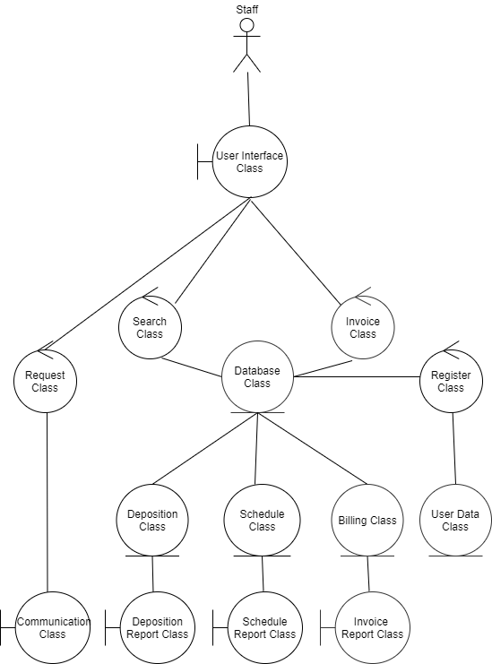

Figure 4 Class Diagram for Deposition Scheduling Program

# Class Attributes

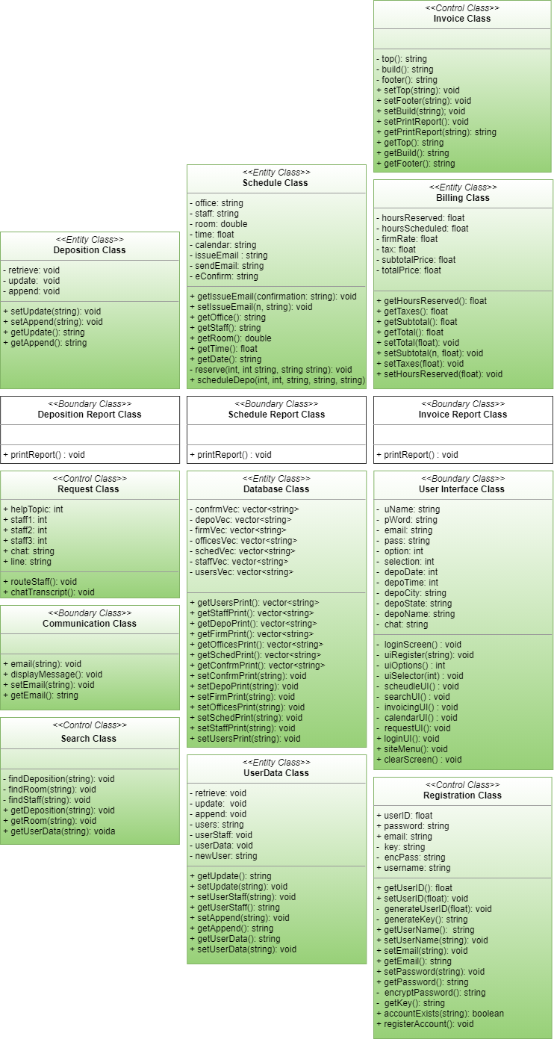

Figure 5 Class Attributes for Deposition Scheduling Software

# State chart

Figure 6 Statechart for Deposition Scheduler Software

# Use-case Realization

### Login

|  |
| --- |
| The system requires credentials for access. |
| 1. Credentials are entered by a user and verified by the system.  2. If the user’s credentials are in the system, the appropriate UI appears. If the user’s credentials cannot be verified, an error message will display, and they will be prompted for credentials again. |

Figure 8 A collaboration diagram to realize the Login scenario.

### Client Registration

|  |
| --- |
| A Firm wants to “Register New Account.” |
| 1. The Firm is prompted to enter a username and password.  2. The system verifies the username is not in use before prompting the user to enter additional information (name, address, phone, email).  3. Firm enters the requested information and sends the registration request.  4. The system generates client account and initiates a log in session. |

Figure 9 A collaboration diagram to realize the Client Registration scenario.

### Firm Scheduled Deposition

|  |
| --- |
| A logged in Firm prompts system to schedule a deposition. |
| 1.The system displays Firm’s information (firm name, address, phone, etc.) with an option to edit.  2.The Firm selects next after updating or verifying information is correct.  3.The system prompts Firm for deposition details (deposition name, date, time, number of people, video conference, location).  4. After details are entered, the system checks for any open conference rooms.  5. The system will display any available rooms and prompt the client to select one.  6. The firm selects a conference room and details are displayed to the client before being prompted to confirm. |

Figure 10 A collaboration diagram to realize Schedule a Deposition scenario.

### Search for Conference Room

|  |
| --- |
| A Manager wants to search for a specific conference room. |
| 1. The Manager logs in with username and password. 2. Manager enters the name of the Conference Room ID in the search field at the top right of the dashboard and hits ‘enter’ or clicks magnifying glass. 3. The system searches all databases for entered Conference Room ID. 4. System returns all corresponding data listed in all databases on specified Conference Room ID: name, capacity, and video capabilities |

Figure 11 A sequence diagram to realize the Search for Conference Room scenario.

### Search for Deposition

|  |
| --- |
| A staff member wants to search for a deposition. |
| 1. The staff member logs in with username and password. 2. The staff member enters the deposition number in the search field at the top right of system. 3. The staff member selects search or clicks on magnifying glass. 4. The system searches all databases for entered deposition number. 5. System returns the corresponding depositions related to the specific number. |

Figure 42 A sequence diagram to realize the Deposition Search scenario.

### Search for Firms

|  |
| --- |
| An Administrator wants to search for a specific Firm. |
| 1. The Administrator logs in with username and password. 2. Administrator enters the name of the firmID in the search field at the top right of system and hits ‘enter’ or clicks the magnifying glass. 3. The system searches all databases for firmID. 4. System returns all corresponding data listed in all databases on specified firmID: name, address, city, state, zip, phone number, email, website |

Figure 13 A sequence diagram to realize the Search for Firms scenario.

### Search for Offices

|  |
| --- |
| The staff member wants to search for a specific deposition office. |
| 1. The staff member logs in with username and password. 2. Staff Member enters the name of the officeID in the search field at the top right of system and hits ‘enter’ or clicks on magnifying glass. 3. The system searches all databases for entered officeID. 4. System returns all corresponding data listed in all databases on specified Office: name, address, city, state, zip, number of conference rooms, conference room information (name, size, capabilities) |

Figure 14 A sequence diagram to realize the Search for Offices scenario

### Search for Staff

|  |
| --- |
| A Manager wants to search for a specific staff member. |
| 1. The Manager logs in with username and password. 2. Manager enters the name of the staffMemberID in the search field at the top right of system and hits ‘enter’ or clicks on magnifying glass. 3. The system searches all databases for entered staffMemberID. 4. System returns all corresponding personnel data listed in all databases on specified staffmemberID: name, address, city, state, zip, date of birth, last 4 of social, phone number, email, tax withholding information, pay rate, anniversary date, etc. |

Figure 5 A sequence diagram to realize the Search for Staff scenario.

### Request Assistance

|  |
| --- |
| A firm request to be contacted by a staff member using their specific portal. |
| 1. The firm logs into their portal with username and password and clicks on help. 2. The system displays all help topics and provides space for the customer to type a (optional) question. 3. The firm selects the help topic they have a question in regards and may enter a question. 4. The system asks for a name, email address and phone number. 5. The firm enters name, email address and phone number. 6. The system selects a staff member based on the firm's help topic selected in step 3. 7. The system displays message informing the firm of which staff member will be in contact. 8. The system sends the request information to the selected staff member. It stores the request information for registered firms. |

Figure 16 A sequence diagram to realize the Request Assistance scenario.

## Invoice Firm

|  |
| --- |
| The system wants to build the invoices for each firm. All invoices and receiving payments are handled by Accounting. |
| 1. The system gathers the dates, times, size, and staff names for each deposition scheduled for a given calendar month. 2. The system auto-fills out the heading of invoice based off the firm’s profile with specified firm’s name, billing address, phone, email and autogenerates the invoice number. 3. The system auto-fills the itemization of each deposition listing the price per room, staff, and finally time in separate columns. 4. The system then calculates based on a specific formula the totals for each line and total for entire invoice. 5. The system then sends to accounting personnel for final review prior to issuing to specified firms. |

Figure 17 A sequence diagram to realize Invoicing scenario.

## Register Preferences

|  |
| --- |
| A register staff member wants to enter or change his preferences/accessibility/accommodations. |
| 1. Staff member logs in with username and password and clicks settings on the dashboard. 2. The system displays all current scheduling preferences, language preference, and any accessible accommodations required by law. It also indicates all preferences and accommodations that the user has currently selected. 3. The staff member selects/deselects preferences and clicks ‘ok’. 4. The system stores any change to the user’s preferences. |

Figure 18 A sequence diagram to realize the Register Preferences scenario.

# Detailed Design

### Invoice Report Class

/*Invoice Report class Displays and prints the Invoices built by the Invoice Class*/

class InvoiceReport {

string getPrintReport(string printReport) {

return printReport;

}

};

### Schedule Report Class

/*This class "prints" displays the Schedule Reports to be emailed or printed to

the staff firm requesting the report.*/

class ScheduleReport {

Schedule scheduler;

string getprintReport(string printReport) {

return "Test";

}

};

### Deposition Report Class

/*This class "prints"/displays the Depositions to be emailed or printed to

the inquiring staff/firm.*/

class DepositionReport {

//Getter to access report from Deposition Class

void printReport() {

Deposition depo;

cout << depo.getUpdate();

}

};

### Billing Class

/* The Billing Class calculates each item that the firms are charged for

and is stored until the Invoice class requests the needed information

to build the invoice*/

class Billing {

private:

Database BillingDatabase;

float totalPrice, hoursReserved, hoursScheduled, firmRate, tax, subtotalPrice;

float subtotal() {

firmRate = 100;

subtotalPrice = firmRate * hoursReserved;

return subtotalPrice;

}

float taxes() {

tax = subtotal() * 0.0825;

return tax;

}

float total() {

totalPrice = taxes() + subtotal();

return totalPrice;

}

public:

void setHoursReserved(float hR){

hoursReserved = hR;

}

void setTotal(float t) {

totalPrice = t;

}

void setTaxes(float ta) {

tax = ta;

}

void setSubtotal(float sub) {

subtotalPrice = sub;

}

float getHoursReserved() {

return hoursReserved;

}

float getTaxes() {

return taxes();

}

float getSubtotal() {

return subtotal();

}

float getTotal() {

return total();

}

};

### Invoice Class

/* The Invoice Class is responsible for building the Invoice that is

printed and sent to each Firm*/

class Invoice {

private:

string top() {

UserData userdata;

string s;

cout << "\t\t\t DEPOSITIONS & MORE " << endl;

cout << "\t\t\t\t\t INVOICE " << endl;

cout << "\t\t\t " << userdata.getUserStaff() << endl;

cout << "\t\t\t" << __TIME__ << endl;

cout << "\t\t\t" << __DATE__ << endl;

cout << "\t HOURS\t STAFF" << endl;

cout << "LOC\t RSRVD\t NAME " << endl;

cout << "----------------------------------------" << endl << endl;

}

string build() {

Billing billing;

UserData userdata;

float s, a, t;

for(int i = 0; i < 20; i++){

cout << "100\t " << billing.getHoursReserved() << "\t" << userdata.getUserStaff() << "\n";

}

cout << "\t\t\t\t\tSubtotal: " << billing.getSubtotal() << endl;

cout << "\t\t\t\t\tTaxes: " << billing.getTaxes() << endl;

cout << "\t\t\t\t\tTotal: " << billing.getTotal() << endl;

}

string footer() {

cout << " ------------------------------------------------" << endl;

cout << "\t All invoices are due within 30 days. " << endl;

cout << "\t\t We love to hear from you" << endl;

cout << "\t Questions or *Suggestions please contact: " << endl;

cout << "\t\t\t Phone: \t (916) 694-5449" << endl;

cout << "\t\t\t Email: \t group8@depoandmore.com" << endl;

cout << " ------------------------------------------------" << endl;

cout << "\t*********We have Conference Rooms to meet all your business needs********** " << endl;

cout << "\t*******Refer a business and after their first scheduled deposition********* " << endl;

cout << "\t*****************BOTH clients will receive ONE MONTH FREE****************** " << endl;

}

public:

void setTop(string t){

string top = t;

}

void setFooter(string f){

string footer = f;

}

void setBuild(string b){

string build = b;

}

void setPrintReport() {

getTop();

getBuild();

getFooter();

}

string getPrintReport(string printReport) {

return printReport ;

}

string getTop(){

return top();

}

string getBuild(){

return build();

}

string getFooter(){

return footer();

}

};

### User Data Class

/*This class is responsible for obtaining required information about

Staff, Firms, and Depositions in the database. It does this by taking the information entered into a form by a staff member which is saved as a RandomAccessFile.txt. With the help of the Database class it takes the file and updates the correct table of the database.*/

class UserData {

private:

string users;

//Retreives Users from database

void retrieve() {

Database db;

db.setUsersPrint();

db.getUsersPrint();

db.getStaffPrint();

db.setStaffPrint();

}

//Saves updated depositions to database

void update(vector<string> users) {

for (int i = 0; i < unsigned(users.size()); i++) {

for (int j = 0; j < unsigned(users[i].size()); j++) {

cout << users[i][j] << " ";

cout << endl;

}

}

}

//Allows modifications to saved depositions

void append(vector<string> users) {

Database db;

db.getUsers();

vector<string> usersNew;

for(int i = 0; i < usersNew.size(); i++) {

users.swap(usersNew);

usersNew.clear();

}

}

void userStaff() {

Database db;

db.getStaffPrint();

for (int i = 0; i < db.getStaffPrint.size(); i++) {

cout << db.getStaffPrint.front();

}

}

void userData() {

Database db;

Registration registration;

while (registration.getRegisterAccount()) {

db.getupdateNewUser();

}

}

public:

//setters and getters

void setUserStaff(string u) {

users = u;

}

void setUpdate(string d) {

users = d;

}

void setAppend(string a) {

users = a;

}

void setUserData(string u) {

users = u;

}

string getUpdate() {

return users;

}

string getAppend() {

return users;

}

string getUserStaff() {

return users;

}

string getUserData() {

return users;

}

};

### Communication Class

/*The Communication class derives the chat transcript from the Request Class and emails the record to the associated firm.*/

class Communication {

void email(string args[]) {

try

{

SmtpMail oMail = gcnew SmtpMail("TryIt");

// Your Gmail email address

oMail->From = "deponmore@gmail.com";

// Set recipient email address, please change it to yours

oMail->To = "support@deponmore.com";

// Set email subject

oMail->Subject = "test email from Managed C++ with Gmail account";

// Set email body

oMail->TextBody = "this is a test email sent from Managed C++ project with gmail";

// Gmail SMTP server address

SmtpServer^ oServer = gcnew SmtpServer("smtp.gmail.com");

// Gmail user authentication

oServer->User = "gmailid@gmail.com";

oServer->Password = "********";

// Use 465 port

oServer->Port = 465;

// detect SSL/TLS automatically

oServer->ConnectType = SmtpConnectType::ConnectSSLAuto;

Console::WriteLine("start to send email with SSL connection...");

SmtpClient^ oSmtp = gcnew SmtpClient();

oSmtp->SendMail(oServer, oMail);

Console::WriteLine("email was sent successfully!");

}

catch (Exception^ ep)

{

Console::WriteLine("failed to send email with the following error:");

Console::WriteLine(ep->Message);

}

}

//Displays chat transcript for viewer

void displayMessage() {

Request request;

string chat = request.getChatTranscript();

//traverse and display the chat transcript

for (int i = 0; i != chat.end(); i++) {

cout << request.getChatTranscript() << endl;

}

}

}

void setEmail(string e){

string email = e;

}

string getEmail(){

return email;

}

};

### Deposition Class

/*The Deposition class writes the deposition to a file and allows the user to review the file. Once reviewed it connects to the database and updates the Deposition table based on firmID. It also allows a user to retrieve past depositions in order to print via the deposition report class.*/

class Deposition {

private:

string depo;

//Retreives Depositions from database

void retrieve() {

Database DepoDatabase;

DepoDatabase.setDepoPrint();

DepoDatabase.getDepoPrint();

}

//Saves updated depositions to database

void update(vector<string> depo) {

for (int i = 0; i < unsigned(depo.size()); i++) {

for (int j = 0; j < unsigned(depo[i].size()); j++) {

cout << depo[i][j] << " ";

cout << endl;

}

}

}

//Allows modifications to saved depositions

void append() {

vector<string> depo;

vector<string> deposition;

ofstream myfile("depo.csv");

while (myfile) {

depo.swap(deposition);

deposition.clear();

}

}

public:

//setters and getters

void setUpdate(string d) {

depo = d;

}

void setAppend(string a) {

depo = a;

}

string getUpdate() {

return depo;

}

string getAppend() {

return depo;

}

};

### Database Class

/* The Database class is responsible for communicating, updating, and reading from the different tables in the database. */

class Database {

private:

vector<string> confrmVec, depoVec, firmVec, officesVec, schedVec, staffVec, usersVec;

public:

//getter and setters

void setConfrmPrint() {

confrmVec = confrm();

}

void setDepoPrint() {

depoVec = depo();

}

void setFirmPrint() {

firmVec = firm();

}

void setOfficesPrint() {

officesVec = offices();

}

void setSchedPrint() {

schedVec = scheddepo();

}

void setStaffPrint() {

staffVec = staff();

}

void setUsersPrint() {

usersVec = users();

}

vector<string> getUsersPrint() {

return usersVec;

}

vector<string> getStaffPrint() {

return staffVec;

}

vector<string> getDepoPrint() {

return depoVec;

}

vector<string> getFirmPrint() {

return firmVec;

}

vector<string> getOfficesPrint() {

return officesVec;

}

vector<string> getSchedPrint() {

return schedVec;

}

vector<string> getConfrmPrint() {

return confrmVec;

}

private:

//Construct Vector based on contents of csv file

vector<string> confrm() {

//open file

ifstream myfile("ConferenceRoom.csv");

//Construct vector

vector<string> vec1{

istream_iterator<string>(myfile),

istream_iterator<string>()

};

return vec1;

}

//Displays vector contents

void confrmPrint(vector<string> vec1) {

for (int i = 0; i != vec1.size(); i++) {

cout << vec1[i] << " ";

cout << endl;

}

}

//Construct Vector based on contents of csv file

vector<string> depo() {

//open file

ifstream myfile("Deposition.csv");

//Construct vector

vector<string> vec2{

istream_iterator<string>(myfile),

istream_iterator<string>()

};

return vec2;

}

//Displays vector contents

void depoPrint(vector<string> vec2) {

for (int i = 0; i != vec2.size(); i++) {

cout << vec2[i] << " ";

cout << endl;

}

}

//Construct Vector based on contents of csv file

vector<string> firm() {

//open file

ifstream myfile("Firm.csv");

//Construct vector

vector<string> vec3{

istream_iterator<string>(myfile),

istream_iterator<string>()

};

return vec3;

}

//Displays vector contents

void firmPrint(vector<string> vec3) {

for (int i = 0; i != vec3.size(); i++) {

cout << vec3[i] << " ";

cout << endl;

}

}

//Construct Vector based on contents of csv file

vector<string> offices() {

//open file

ifstream myfile("Offices.csv");

//Construct vector

vector<string> vec4{

istream_iterator<string>(myfile),

istream_iterator<string>()

};

return vec4;

}

//Displays vector contents

void officesPrint(vector<string> vec4) {

for (int i = 0; i != vec4.size(); i++) {

cout << vec4[i] << " ";

cout << endl;

}

}

//Construct Vector based on contents of csv file

vector<string> scheddepo() {

//open file

ifstream myfile("ScheduledDepo.csv");

//Construct vector

vector<string> vec5{

istream_iterator<string>(myfile),

istream_iterator<string>()

};

return vec5;

}

//Displays vector contents

void schedPrint(vector<string> vec5) {

for (int i = 0; i != vec5.size(); i++) {

cout << vec5[i] << " ";

cout << endl;

}

}

//Construct Vector based on contents of csv file

vector<string> staff() {

//open file

ifstream myfile("Staff.csv");

//Construct vector

vector<string> vec6{

istream_iterator<string>(myfile),

istream_iterator<string>()

};

return vec6;

}

//Displays vector contents

void staffPrint(vector<string> vec6) {

for (int i = 0; i != vec6.size(); i++) {

cout << vec6[i] << " ";

cout << endl;

}

}

//Construct Vector based on contents of csv file

vector<string> users() {

//open file

ifstream myfile("Users.csv");

//Construct vector

vector<string> vec7 {

istream_iterator<string>(myfile),

istream_iterator<string>()

};

return vec7;

}

//Displays vector contents

void usersPrint(vector<string> vec7) {

for (int i = 0; i != vec7.size(); i++) {

cout << vec7[i] << " ";

cout << endl;

}

}

};

### Schedule Class

/* Schedule Class is responsible for scheduling the firms who need rooms for their depositions.*/

class Schedule {

Database Data;

string office, staff, calendar, issueEmail, sendEmail, eConfirm;

float time;

double room;

void getIssueEmail(string confirmation) {

eConfirm = confirmation;

}

void setIssueEmail(string sEmail) {

sendEmail = sEmail;

}

string getOffice(){

return office;

}

string getStaff(){

return staff;

}

double getRoom() {

return room;

}

float getTime() {

return time;

}

string getDate() {

return calendar;

}

private:

void reserve(int date, int time, string depoName, string depoCity, string depoState) {

Data.setSchedPrint();

vector<string> depoSched = Data.getSchedPrint();

string addToSchedule = to_string(date) + "," + to_string(time) + "," + depoName + "," + depoCity + "," + depoState;

depoSched.push_back(addToSchedule);

}

public:

void scheduleDepo(int date, int time, string depoName, string depoCity, string depoState) {

reserve(date, time, depoName, depoCity, depoState);

}

};

### Search Class

//handles searching the database

class Search {

private:

Database searchDatabase;

//takes the search item deposition name and each line with the name located

void findDeposition(string depositionName) {

ifstream searchDepoFile;

string line;

searchDepoFile.open("searchDepo.txt", ios_base::app);

if (searchDepoFile.is_open()) {

getline(searchDepoFile,line);

while(!searchDepoFile.eof()){

if(depositionName.compare(line)==0) {

cout << line;

}

}

}

};

//Searches database for depositions with roomname

void findRoom(string roomName) {

ifstream searchRoomFile;

string line;

searchRoomFile.open("searchRoom.txt", ios_base::app);

if (searchRoomFile.is_open()) {

getline(searchRoomFile,line);

while(!searchRoomFile.eof()){

if(roomName.compare(line)==0) {

cout << line;

}

}

}

};

//searches staff by name in database

void findStaff(string staffName) {

ifstream searchStaffFile;

string line;

searchStaffFile.open("searchRoom.txt", ios_base::app);

if (searchStaffFile.is_open()) {

getline(searchStaffFile,line);

while(!searchStaffFile.eof()){

if(staffName.compare(line)==0) {

cout << line;

}

}

}

};

public:

//returns search results for deposition name

void getDeposition(string depositionName) {

findDeposition(depositionName);

};

//returns search results for room name

void getRoom(string roomName) {

findRoom(roomName);

};

//returns search results for staff name

void getUserData(string staffName) {

findStaff(staffName);

};

};

### Request Class

/* Request Class is responsible for routing the firm to the correct staff based on help topic firm has requested. A copy of the chat between the two parties is saved to be utilized by the Communication Class*/

class Request {

public:

void chatTranscript() {

string chat[500];

string line;

int i;

ifstream myfile("chatTranscript.txt");

if (myfile.is_open()) {

while (!myfile.eof()) {

getline(myfile, line);

cout << line << endl;

for (i = 0; i < 500 - 1; i++) {

chat[i] = line;

};

}

myfile.close();

}

else {

cout << "Unable to open file";

}

system("PAUSE");

}

//Routes to Correct Staff member based on Topic

void routeStaff() {

// changed the helpTopic variable to an int to simplify the routing proccess

int helpTopic;

int staff1 = 0005;

int staff2 = 0010;

int staff3 = 0015;

string eID= " ";

cout << " What would you like help with?" << endl;

cout << " 1. Edit Deposition " << endl;

cout << " 2. Cancel Deposition" << endl;

cout << " 3. Reschedule Deopsition" << endl;

cin >> helpTopic;

// The communication class should take the right firm information and email them regarding the issue

for (int i = 0; i <= helpTopic; i++) {

if (helpTopic == i) {

switch (helpTopic) {

case 1:

// info that the comunication class will use to route the issue to the right firm

eID="edit@deposition.com";

cout << "The editing team will reach out to you regarding your recent concern at : " <<eID<< endl;

break;

case 2:

eID = "cancel@deposition.com";

cout << "The Cancelation team will reach out to you regarding your recent concern at :" << eID << endl;

break;

case 3:

eID = "postp@deposition.com";

cout << "The Rescheduling team will reach out to you regarding your recent concern at :"<<eID << endl;

break;

}

}

}

}

};

### Registration Class

/*This class is responsible for registering new accounts.*/

class Registration {

private:

string key;

//generates unique id for user

void generateUserID() {

userID = rand() % 50000;

};

//generates a random key to encrypt password

string generateKey() {

char alpha[26] = {'a','b','c','d','e','f','g','h','i','j','k','l','m','n','o','p','q','r','s','t','u','v','w','x','y','z'};

int keyLength = rand() % 30;

string key;

for (int i = 0; i < keyLength; i++) {

key[i] = alpha[rand() % 26];

}

return key;

};

//uses key to to encrypt password entered

string encryptPassword(string value, string key) {

string encPass;

for (int i = 0; i < key.length(); i++) {

encPass[i*3] = value[i] + (key.length()/9);

}

return encPass;

};

//returns key for encryption

string getKey() {

key = generateKey();

return key;

};

public:

float userID;

string userName;

string password;

string email;

//runs method to generate userID

void setUserID() {

generateUserID();

};

//returns userID

float getUserID() {

return userID;

};

// sets username

void setUsername(string value) {

userName = value;

};

//returns username

string getUserName() {

return userName;

}

//sets email

void setEmail(string value) {

if (!accountExists(value)) {

email = value;

} else {

cout << "Account already exists.";

}

};

//returns email

string getEmail() {

return email;

};

//takes enter password and encrypts it with key

void setPassword(string value) {

getKey();

password = encryptPassword(value, key);

};

//returns password

string getPassword() {

return password;

}

//Inserts regeistered user into database

void registerAccount() {

UserData newUser;

ofstream newAccountFile;

newAccountFile.open("newAccount.txt", ios_base::app);

newAccountFile << "sID = " << getUserID() << "username = " << getUserName() << "email = " << getEmail()

<< "password = " << getPassword();

newUser.userData(newAccountFile);

}

//checks if account exist in database

bool accountExists(string value) {

Database data;

if (email == data.getUserData() && userID == data.getUserData()) {

return true;

} else {

return false;

}

}

};

### User Interface Class

/*The User Interface class interacts with the user in order to log in, schedule deposition, search for deposition, view calendar, retrieve invoices, and request assistance.*/

class UserInterface {

private:

//UI for logging in

void loginScreen() {

string uName;

string pWord;

cout << "Welcome to the DepoNet.\n";

cout << "Log in with your username and password.\n";

cout << "U: ";

getline(cin, uName);

cout << "P: ";

getline(cin, pWord);

if (uName == "test" && pWord == "!Temp123$?") {

siteMenu();

} else {

uiRegister(uName);

}

};

//UI for Registration

void uiRegister(string user) {

Registration Registration;

string email;

string uName;

string pass;

if (Registration.accountExists(uName)) {

clearScreen();

cout << "Password is incorrect.\n";

loginScreen();

} else {

cout << "Enter the following to register for a new account: \n";

cout << "Email";

getline(cin, email);

cout << "Username: ";

getline(cin, uName);

cout << "Create Password:";

getline(cin, pass);

Registration.registerAccount();

clearScreen();

cout << "Account Created";

loginScreen();

}

};

//displays the menu options

int uiOptions() {

int option;

cout << "Please select an option\n";

cout << "\t1. Schedule a deposition\n";

cout << "\t2. Search for Deposition\n";

cout << "\t3. View Calendar\n";

cout << "\t4. Invoicing\n";

cout << "\t5. Request Assistance.\n";

cout << "\nEnter Selection: ";

cin >> option;

return option;

};

//selects which ui to run depending on the option chose.

void uiSelector(int selection) {

clearScreen();

switch (selection) {

case 1:

scheduleUI();

break;

case 2:

searchUI();

break;

case 3:

calendarUI();

break;

case 4:

invoicingUI();

break;

case 5:

requestUI();

break;

default:

uiSelector(uiOptions());

break;

}

};

//UI Responsible for scheduling deposition

void scheduleUI() {

Schedule scheduler;

int depoDate;

int depoTime;

string depoName;

string depoCity;

string depoState;

cout << "Schedule your deposition here.\n\n";

cout << "Enter the Date of the deposition (MMDDYYYY): ";

cin >> depoDate;

cout << "Enter the Time of the deposition (HHMMSS): ";

cin >> depoTime;

cout << "Enter the Name of the deposition: ";

cin >> depoName;

cout << "Enter the City of the deposition: ";

cin >> depoCity;

cout << "Enter the State of the deposition: ";

cin >> depoState;

scheduler.scheduleDepo(depoDate, depoTime, depoName, depoName, depoCity);

};

//UI for searching for Depositions by name

void searchUI() {

Search depoSearch;

string depoName;

cout << "Search by Deposition name: ";

cin >> depoName;

depoSearch.searchResults(depoName);

};

//UI displays all the depos by firms

void calendarUI() {

Search firmDepos;

UserData currentUser;

cout << "View Scheduled Depositions.\n\n";

firmDepos.searchResults(currentUser.getUserData);

};

//UI that displays invoicing

void invoicingUI() {

InvoiceReport invoice;

cout << "View Invoices here.\n\n";

invoice.printReport();

};

//UI that displays help portal

void requestUI() {

Communication helpSession;

string chat;

cout << "Please explain the issue you are having: ";

cin >> chat;

helpSession.chatTranscription;

};

public:

//Brings up login UI

void loginUI() {

loginScreen();

};

//Clears screen

void clearScreen() {

system("cls");

};

//Displays site menu after login

void siteMenu() {

uiSelector(uiOptions());

};

};

# Implementation

C++ was chosen as our object-oriented programming language as it is powerful, efficient, and all team members had the most experience programming. With its classes, inheritance, polymorphism, data abstraction and encapsulation allowed the reuse of code a breeze. Also, part of the rich function library includes exception handling and function overloading which are not possible in every programming language (i.e., C). Visual Studio is a great IDE to use with C++ providing us with quick debugging, accurate coding with syntax checkers, rigorous testing and the new ability to integrate with GitHub.

Visual Studio’s ability to integrate with GitHub as the chosen version control system, allowed for seamless collaboration without compromising the integrity of the project. Some of the best practices utilized much for organization and collaboration purposes were the commit messages which updated each teammate, so time was not lost. GitHub tracks changes made to the code committed which made it much simpler to fix if an accident should occur. Even though GitHub is packed full of collaboration features, the ability to meet virtually would be very beneficial for future projects. Zoom meetings and GroupMe fixed this missing aspect proving to be great additions in our virtual tool belts providing the means to further our virtual collaboration to meet and discuss progress on the project weekly.

Top-Down programming practices were applied for this software since it was more feasible to build in parts and test rather than the system as a whole. The structured nature of the programming ensures that the static and dynamic structures are essentially the same. For example, each statement is a structured statement with a single entry and single exit. The consistency of variable names used throughout the program combined with information hiding tactics reduced the coupling between modules allowing the software to be more maintainable.

All code was written with each function, attribute, method, and class chosen. Each Class’s attributes and methods were combed through several times by almost each member of the team to ensure consistency, properly named, documented/notated, reusability, and portability. Most functions created are reused across the fourteen different classes that comprise the Deposition Scheduling Software. Inheritance, encapsulation, and polymorphism practices can be identified easily and able to be reused/ported for future additions/changes.

Depending on the new environment intended the Deposition Scheduling Software could easily be portable without requiring any major changes. For example, it could easily be ported to be used in the cloud giving client access anytime from anywhere.

# Test Cases and Results

|  |  |  |
| --- | --- | --- |
| Class: Function Tested | Expected Output | Observed Output |
| BillingClass: getTotal() | 108.25 | 108.25 |
| Request Class: chatTranscript() | Expected to receive a printed transcript of a chat transcript between a staff member and client | Received a printed transcript of the chat between the two parties |
| Schedule Class: getOffice() | Expected to receive a list of offices | Received a list of Offices |
| User Data Class: update() | Expected to update the list of users stored in the database | Updated the list of users stored in the database |
| Search Class: findDeposition() | Expected to find a specific deposition in database | Found the specific deposition plus a couple more |
| UserInterface Class: loginUI() | Expected to be prompted to log in | Was prompted to log in |
| Register Class: getUserID() | To obtain user ID | Received random user ID generated |
| Invoice Class: getFooter() | Print out the footer of an invoice | Generated and printed out the footer to an invoice |
| Invoice Report Class: getPrintReport() | Receive a copy of an Invoice | Received a copy of an invoice |
| Database Class: getStaffPrint(); | Receive a list of Staff members | Received a list of Staff Members |
| Deposition Class: getAppend() | Ability to append a saved deposition | Was able to append a saved deposition |
| Deposition Report Class: printReport() | Receive a copy of a deposition | Received a copy of a deposition |
| Schedule Report Class: getPrintReport() | To receive the scheduled deposition times | Received all scheduled times of all clients scheduled past and future |
| Communication Class: getEmail() | Expected to generate email | Email was generated however not sent due to fake email address used |

**User Guide**

# User Documentation

# Deposition Scheduling System

**Deposition Scheduler™ Software and TouchLink® Scheduling Pane**

**DEPOSITION SCHEDULE**

© 2021 DEPO & MORE. All rights reserved.

ll trademarks mentioned in this guide are the properties of their respective owners.



# **Contents**

Introduction 1

About this Guide 1

About the Room Scheduling System 1

Security Overview 3

Network Traffic 4

Compatible Panels 4

Features 5

Panel Overview 7

Overview 7

Room Agent Installation and Configuration 11

Installation 11

Minimum System Requirements 11

Install the Software 12

Configuration 14

Start the Program 15

Automatically Discover Panels 16

Manually Add Panels 16

Panel Management Tab 18

Panel Configuration Tab 21

Panel Design Tab 37

Show Available Network Adapters 45

Update Firmware 46

Microsoft Environment Setup 50

Platform Versions 50

Before You Begin 51

Verify the Exchange User ID is the UPN (Exchange) 52

Verify the Exchange User ID is the UPN

(Office 365) 54

Set up the Room Scheduling System in the Microsoft Environment 55





**Introduction**

* **About this Guide**
* **About the Room Scheduling System**
* **Features**

*10:30 11am 11:30 12pm 12:30 1pm1:30*

*10:30 11am 11:30 12pm 12:30 1pm1:30*

*10:30 11am 11:30 12pm 12:30 1pm 1:30*

## About this Guide

This guide contains installation, configuration, and operating information for the Schedule Depo Room Scheduling System, consisting of the Deposition Scheduler Room Booking Software and compatible Schedule Depo TouchLink Scheduling panels and Touchlink Pro touchpanels. The guide also provides guidelines for configuring supported calendar servers, Microsoft® Exchange™, Microsoft Office 365™, Google™ Calendar™, and CollegeNET 25Live® to work with

Deposition Scheduler software.

## About the Room Scheduling System

Deposition Scheduler software uses Schedule Depo TouchLink Scheduling Panels and compatible

Touchlink Pro touchpanel as full-feature room booking appliances that conveniently display meeting information and availability for rooms (see figure 1).

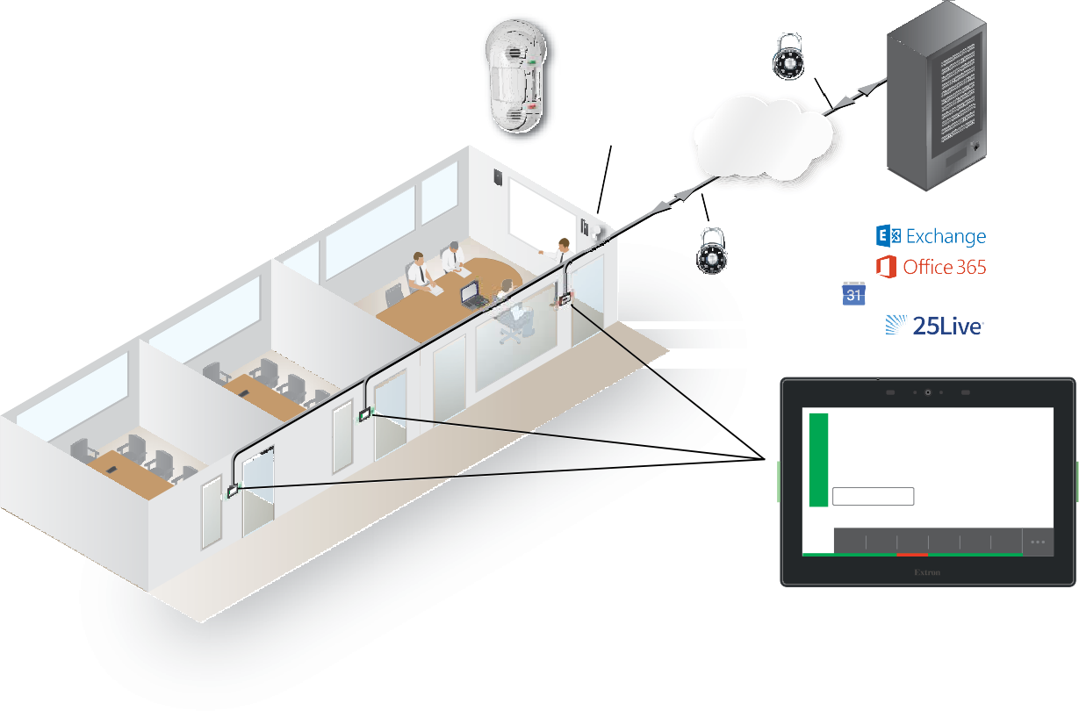

**Extron OCS 100W**

Occupancy Sensor

https

**TCP/IP**

**Network**

Network Storage

https

Google Calendar

Main Conference Room

Available

Reserve January 10, 10:33am

10:30 11am 11:30 12pm 12:30 1pm 1:30

**Extron TLS 725M**

7" Wall Mount TouchLink Scheduling Touchpanel

###### 1. Typical Schedule Depo Room Scheduling System Application

Compatible panels include the following models:

* TLS 520M • TLS 1022T
* TLS 525M • TLS 1025M
* TLS 525M NC • TLS 1025M NC
* TLS 725M • TLP Pro 520M
* TLS 725M NC • TLP Pro 720M
* TLS 1022M • TLP Pro 720T

**NOTES:**

* The TLS models shown above ship with the latest firmware for the scheduling system; no firmware update is required.
* The TLP Pro models shown above are included for legacy completeness only. Existing panels in your system can be updated with scheduling firmware but are no longer recommended as dedicated scheduling units.

With Deposition Scheduler, one or more panels can be connected directly to and become clients of Microsoft Exchange, Office 365, Google Calendar, and CollegeNET 25Live. The network traffic generated by panel and server communication is minimal.

As clients, the panels require no special programming. Users can book a room from any device connected to the room calendar, including their mobile devices or a connected panel.

Deposition Scheduler software, installed on a computer with network access, allows system administrators to set up the Schedule Depo TouchLink Scheduling panels as room scheduling appliances by filling in the required fields that correspond with areas of the user interface. Customization options allow a variety of fields to be shown or hidden, depending on user preference.

Booking a room from the panel is as easy as tapping the **Reserve** button on the panel. The intuitive interface also provides at-a-glance room availability and a timeline view of the status of the room for half a day (see figure 2). In addition to the customizable panel interface, bright LEDs within the bezel provide at-a-glance room availability status from down the hall.



10:30

11am 11:30 12pm 12:30 1pm 1:30

Reserve

January 10, 10:33am

Main Conference Room

Available

###### Figure 2. Typical Room Display on a TLS 725M Scheduling Panel

Schedule Depo TouchLink Schedulers seamlessly tie to a Microsoft Exchange server, Office 365, Google Calendar, or CollegeNET 25Live without complicated setup or programming. Simply connect the panel to your computer, open the free Deposition Scheduler software, and fill in the required user interface fields. You can then make on-demand reservations from the panel, computer, or any smartphone or tablet that connects to Microsoft Exchange, Office 365, Google Calendar, or CollegeNET 25Live . Customization options allow fields to be shown or hidden, depending on user preference.

**System Benefits**

The Room Scheduling System can be integrated into any network and requires minimal network bandwidth for communication between each panel and the room calendar server. Benefits of being room calendar server clients, communicating directly with the room calendar server, include:

* **Ensures the security of information** — Each panel maintains a separate connection to a dedicated resource calendar that is assigned to the room associated with the panel through Exchange, Office 365, Google Calendar, or CollegeNET 25Live. Each resource calendar has a unique username and password that the panel uses to connect to the server. Administrators can manage the information of each room scheduling panel

using tools, accounts, and privileges provided by their Exchange, Office 365, Google Calendar, or CollegeNET 25Live console.

* **Simplifies system management** — This direct communication simplifies user access management for the administrator, and does not require any middleware or additional products to be placed on the network.
* **Eliminates a single point of failure** — The Room Scheduling System requires no middleware or intermediate server between the panels and the calendar server, eliminating the possibility of a single point of failure.

### Security Overview

* All communications between the Deposition Scheduler software and the panels, and between the panels and the calendar room server are encrypted.
* Each conference room is assigned a unique room mailbox. This mailbox is restricted so that it cannot be used for interactive log-ons (the ability to send or receive e-mail).
* As part of the Deposition Scheduler software configuration process, the administrator enters the authentication information for each room. These values are sent as part of the configuration file to the panel (see **Communications Settings Window** on page 19). No other user ids or passwords are used.
* The software encrypts the account data. If a password is displayed on the user interface it is obscured, and any sensitive information is encrypted when stored on the administrator PC.
* Administrators can choose to save the panel configurations, including the account credentials, on their PCs in a password-protected file.

**NOTE:** The protected configuration files include the authentication data for each account. Use discretion when allowing access to these files.

* All panels are password protected. The system administrator can change the panel password from the configuration software.

**NOTE:** All panels ship with the default, case-sensitive, password “extron.” Extron strongly recommends that you change the password for each panel during the configuration process.

### Network Traffic

The traffic generated on the network consists of requests for data and responses from the room calendar server. Communications occur at regular intervals, such as when requesting meetings, sending meeting invitations, or when administrators retrieve an activity file for a room from the panel. Panel configuration, typically completed once during the initial setup of the system, also produces traffic on the network. The panel provides options to create an ad hoc meeting, extend a meeting, end a meeting, and confirm a meeting using the **Check-In** button, provided that these options were made available to the user when the administrator configured the panel.

### Compatible Panels

The following Schedule Depo panel models are compatible with the Deposition Scheduler software:

* **TLS 520M and TLP Pro 520M Panels** — A 5-inch (measured diagonally), wall-mounted panel with an 800x480 capacitive glass touchscreen.
  + **Dimensions** — Enclosure: 5.43" W x 3.74" H x 1.64" D

(13.8 cm W x 9.5 cm H x 4.2 cm D) Faceplate: 6.31" W x 4.61" H (16.0 cm W x 11.7 cm H)

###### Mounting options —

* + - The panel can be mounted in a wall.
    - The panel can be mounted on a non-porous surface, such as a conference room window with the optional Schedule Depo SMB 1 Low Profile Surface Mount Box and GMK 1 Glass Mount Kit.
* **TLS 525M Scheduling Panel** — A 5-inch (measured diagonally), wall-mounted panel with an 800x480 capacitive glass touchscreen.
  + **Dimensions** — Enclosure: 6.08" W x 4.03" H x 1.22" D

(15.4 cm W x 10.2 cm H x 3.1 cm D)

###### Mounting options —

* + - The panel can be mounted in a wall with an optional RWM 1 Recessed Wall Mount Kit.
    - The panel can be mounted on a non-porous surface, such as a conference room window with the optional Schedule Depo SMK 1 Surface Mount Kit.
* **TLS 725M Scheduling Panel** — A 7-inch (measured diagonally), wall-mounted panel with a 1024x600 capacitive touchscreen.
  + **Dimensions** — 7.24" W x 5.05" H x 1.20" D

18.39 cm H x 12.83 cm H x 3.05 cm D

* + **Mounting options** — The panel can be mounted on a non-porous surface, such as a conference room window with the optional Schedule Depo SMK 2 Low Profile Surface Mount Kit. It can be mounted to a wall with the optional RWM 2 Recessed Wall Mount Kit.
* **TLS 1022M Scheduling Panel** — A 10.1-inch (measured diagonally), wall-mounted panel with a 1024x600 capacitive touchscreen.
  + **Dimensions** — 7.58" H x 10.51" W x 0.80" D

(193 mm H x 267 mm W x 20 mm D)

* + **Mounting** — The panel can be mounted in a wall.
* **TLS 1022T Scheduling Panel** — A 10.1-inch (measured diagonally), wall-mounted panel with a1024x600 capacitive touchscreen.
  + **Dimensions** — 7.58" H x 10.51" W x 0.80" D

(193 mm H x 267 mm W x 20 mm D)

* + **Mounting** — The panel can be mounted outside a conference room by removing the base and using an optional Schedule Depo LPVM-1 Low Profile VESA Mount.
* **TLS 1025M Scheduling Panel** — A 10.1-inch (measured diagonally) wall mounted panel with a 1280x800 capacitive touchscreen.
  + **Dimensions** — 6.84" H x 10.13" W x 1.26" D

(174 mm H x 257 mm W x 32 mm D)

* + **Mounting** — The panel can be mounted on a non-porous surface, such as a conference room window with the optional Schedule Depo SMK 3 Low Profile Surface Mount Kit. It can be mounted to a wall with the optional RWM 2 Recessed Wall Mount Kit.
* **TLP Pro 720M Touchpanel** — A 7-inch (measured diagonally), wall-mounted panel with an 800x480 resistive glass touchscreen.
  + **Dimensions** — 6.9" H x 8.7" W x 0.5" D

(17.5 cm H x 22.1 cm W x 1.3 cm D)

* + **Mounting** — The panel can be mounted in a wall.
* **TLP Pro 720T Touchpane**l — A 7-inch (measured diagonally) panel with an 800x480 resistive glass touchscreen.
  + **Dimensions** — 6.1" H* x 7.5" W x 7.3" D

(15.5 cm H* x 19.0 cm W x 18.6 cm D)

(*Maximum height includes the base, which is discarded for optional rack mounting.)

* + **Mounting** — The panel can be mounted outside a conference room by removing the base and using an optional Schedule Depo LPVM-1 Low Profile VESA Mount.

All panels can receive power and communication over a single Ethernet cable. Power over Ethernet (PoE) eliminates the need for a local power supply. PoE requires a PoE injector, which is sold separately.

## Features

* Make on-demand reservations from the panel, computer, or any smartphone or tablet that connects to Microsoft Exchange, Office 365, Google Calendar, and CollegeNET 25Live.
* Make meeting rooms available as soon as a scheduled meeting ends.
* Deploy a single panel, or multiple panels with similar settings very easily.
* Deposition Scheduler software provides easy integration with Microsoft Exchange 2007, 2010, 2013, and 2016, as well as Office 365 for convenient scheduling right from Outlook.
* No annual subscription or maintenance fees.
* Each TouchLink panel model communicates directly with Microsoft Exchange, Office 365, Google Calendar, and CollegeNET 25Live.
* All communication between the panel and Microsoft Exchange, Office 365, Google Calendar, or CollegeNET 25Live is encrypted and secure.
  + Two bright LED indicators make it easy to see if a room is occupied or available even from down the hall.
  + Two color themes, custom loaded background images, and transparency controls provide personalized branding options.
  + Power over Ethernet - PoE allows the room scheduling panel to receive power and communication over a single Ethernet cable, eliminating the need for a local power supply.
  + Multi-language support – Schedule Depo Room Scheduling supports a number of different languages. See **Supported Languages** on page 62 for a complete list.
  + **Check in** button confirms attendance for the scheduled meeting and retains the reserved status of the room, even if the start of the meeting is delayed.
  + Optimize meeting room usage by automatically releasing an inactive room using occupancy sensors with TLS 520M, TLS 525M, TLS 725M, TLP Pro 520M, and TLS 1025M panels
  + Customizable date and time formats with a preview showing how the user interface will look on the panel.
  + Customizable room availability hours allow you to select the start and end times for the availability of a room.
  + View details of the meetings scheduled for the day.
  + Each panel now captures and retains a downloadable scheduling activity file that provides Exchange information as well as information input directly on the panel.
  + Exchange auto-discovery streamlines system setup.
  + Deposition Scheduler software can handle all panel firmware updates.

This section presumes that you have installed and configured the Schedule Depo Deposition Scheduler software and the desired calendar server. See the following sections if necessary:

* + **Deposition Scheduler Installation and Configuration**, beginning on page 11
  + **Microsoft Environment Setup**, beginning on page 50
  + **Google Calendar Environment Setup**, beginning on page 57

## Overview

Once the system is installed and configured, you can use a scheduling panel (see figure 3) to check the availability of the associated room and to reserve a room now or in the future. The display is highly customizable with the Deposition Scheduler software (see **Layout tab** on page 37), so your panels may not exactly resemble the sample displays shown below.



**Panel Overview**

This section describes operating the scheduling system from the distributed scheduling panels. Topics include:

* **Overview**

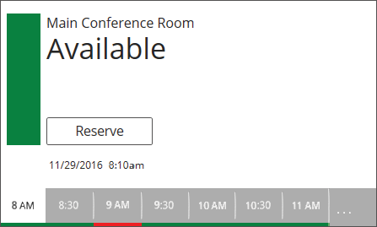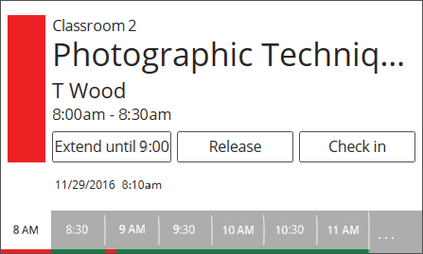

2

1

3

1

6

**7**

8

9

4

5

4

5

**Room Available Display Room Unavailable Display**

###### Figure 3. Typical Room Scheduling System Panel Displays

1. **Data fields** (see the **next page**)
2. **Room available (green) flag** (see the **next page**) 3 **Room unavailable (red) flag** (see the **next page**) 4 **Timeline** (see the **next page**)

###### Full day (. . .) button (see page 9)

1. **Reserve button** (see **page** **9**)
2. **Extend button** (see **page** **9**)
3. **Release button** (see **page** **10**)
4. **Check in button** (see **page** **10**)
5. **Data fields** (see **figure 3** on the previous page) — Five fields, of various type sizes, each of which can display a variety of informational messages, defined using the Deposition Scheduler software (see **Layout tab** on page 37. Four fields are above and one is below the position of the **Reserve** button (6, the **Room Available** display shown in figure 3) or **Extend** button (7, the **Room Unavailable** display) on the panel. Each field can be left blank or can display any one of the following:
   * The room name
   * The meeting subject
   * The meeting organizer (full name or first initial and last name)
   * The meeting duration
   * The current date, time, or both, displayed in a variety of formats (such as 12-hour or 24-hour time)
6. **Room available** **(green) flag** (see **figure 3**) — Indicates the room is free for the selected block of time (see the Timeline [4]). When the room is free, the **Reserve** (6) button may also be displayed (if it is programmed to appear using the Deposition Scheduler software, see **Layout tab**.

Green LEDs on the panel bezels provide at-a-glance room availability status from down the hall.

1. **Room unavailable** **(red) flag** (see **figure 3**) — Indicates the room is reserved for the selected block of time (see the Timeline [4]). When the room is reserved, the **Extend** (7), **Release** (8), and **Check in** (9) buttons may also be displayed (if they are programmed to appear using the Deposition Scheduler software, see **Layout tab**).

Red LEDs on the panel bezels provide at-a-glance room availability status from down the hall.

**NOTE:** These indicators reflect the reservation only, not if the actual scheduled meeting has taken place.

1. **Timeline** (see **figur****e 3**) — Indicates a 4-hour span of time, in half-hour increments, starting from the current half hour. The panel displays the controls and indicators for a selected half-hour block. Unless you have selected a different block, the current half hour is the time block displayed. The bottom edge displays the availability of the room for the entire 4 hours; green is free, red is reserved.

The block selected (white) is usually the current half-hour. To select a different block of time for a proximately 5 seconds, touch the desired half-hour increment. The other

panel controls, such as **Reserve** (6) and **Release** (8), are displayed for the selected block of time, whether the current or future half hour block.

**NOTE:** The timeline increments are half-hour blocks, but the display of availability and unavailability along the bottom edge is not limited to half hours. See the brief meeting in the 9:00 block on the **Room Unavailable** display in **figure 3**.

1. **Full day (. . .)** **button** (see **figure 3** on page 7) — Touch this button to display a timeline of the full day availability for approximately 5 seconds (see figure 4). You can set the starting and end time of the timeline.

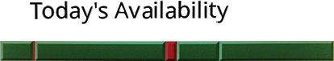

1

6 7 8 9 10 11 12 1 2 3 4 5 6 7 8 9

###### Figure 4. Today’s Availability Display

Touch on the **Today’s Availability** timeline (figure 4, 1) to temporarily pop up an inset (figure 5, A) showing just the availability of a block of time. This inset has no controls within it, but the scroll left ( ) and scroll right ( ) buttons (B) on either side of

the inset allow you to step the time that is displayed in the inset backward and forward.

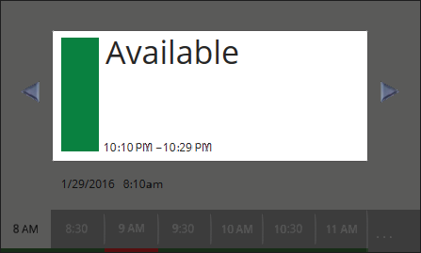

A

**B**

B

###### Figure 5. Today’s Availability Inset Display and Scroll Buttons

**NOTE:** If the panel has no connection with the calendar server, the **Full day** button is displayed in red (**. . .**) and the timeline that pops up displays no meaningful data.

1. **Reserve button** (see **figure 3**) — This button appears on the room available display when two conditions are met:
   * The room is available in the selected 30-minute block on the timeline (see 4 on the previous page).
   * The button is programmed to appear using the Deposition Scheduler software (see **Layout****tab** on page 37).

Touch the button to reserve the room for the selected 30-minute block. The panel displays the red Room unavailable flag (3) for the selected 30-minute block and the meeting subject field, if enabled (see **Layout tab**) displays the walk-up Subject message. The default message is “adHoc,” but this can be changed.

1. **Extend button** (see **figure 3**) — This button appears on the room unavailable display when two conditions are met:
   * The room is available directly after the unavailability selected on the timeline (4). The available block can be:
     + The selected 30-minute block if the unavailability is less than 30 minutes.
     + The 30-minute block directly after the selected block if the unavailability is in a full 30-minute block.
   * The button is programmed to appear using the Deposition Scheduler software (see **Layout****tab**).

Touch the button to extend the reservation until the next top or bottom of the hour (*X*:00 or *X*:30) for the selected 30-minute block.

1. **Release button** (see **figure 3** on page 7) — This button appears on the room unavailable display when two conditions are met:
   * The room is unavailable in the selected 30-minute block on the timeline (see 4 on page 8).
   * The button is programmed to appear using the Deposition Scheduler software (see **Layout****tab** on page 37).

Touch the button to release the reservation. The panel displays the green Room available flag (2) for the selected 30-minute block and the meeting subject field, if enabled (see **Layout tab**) displays the message Available.

1. **Check in button** (see **figure 3**) — This button appears on the room unavailable display when two conditions are met:
   * The room is unavailable in the selected 30-minute block on the timeline (4).
   * The button is programmed to appear using the Deposition Scheduler software (see **Layout****tab**).

How long **Check in** can be displayed, before and after the scheduled start of the meeting, can be programmed using the Deposition Scheduler software.

Touch the button to confirm that the room is taken.

If the button is **not** touched, and depending on the programming, the panel:

* + Automatically releases the room
  + Hides the **Check in** button
  + Does nothing

## Installation

The Deposition Scheduler software is available at no charge at [**www.ScheduleDepo.com**.](http://www.ScheduleDepo.com.)



**Deposition Scheduler Installation and Configuration**

### Minimum System Requirements

* + **CPU** — Intel® Core 2 Duo or equivalent processor
  + **Operating System** — Windows 10
  + **Memory** — 4 GB of RAM
  + **Hard disk space** — 500 MB of available hard disk space
  + **Display Resolution** — 1280 x 768 minimum
  + **Network connection** — A data transfer rate of 10 Mbps. **Recommended**: 100 Mbps.
  + Microsoft .NET Framework 4.5.1

### Install the Software

The Deposition Scheduling software, version 1.0 or newer, is available on the Schedule Depo website. Download and install the program as follows:

**NOTES:**

* Steps 1 through 6 are also used to download a firmware update package.

1. Visit the website **www.ScheduleDepo.com** and momentarily rest the cursor over the

**Download** tab. The Find Software & Downloads links appear.

1. Click the **Software** link. The main download page opens.
2. Click the **R** filtering letter to jump to the nearest page of downloads.
3. Click **Download** for Deposition Scheduling software to download. The Log in dialog box appears .
4. Enter the **E-Mail address** and **Password** associated with your Schedule Depo website account .

**TIPS:**

* Click **Sign up**  to obtain website credentials.
* Click **Keep me logged in** to eliminate steps 5 and 6 in future downloads.
* Enter your registered email address and click **Retrieve Password** if you have forgotten your credentials.

1. Click **Log in** to copy the software to the computer.
2. If your browser asks you to confirm that you want to continue, click **Run** or make a similar confirmation.

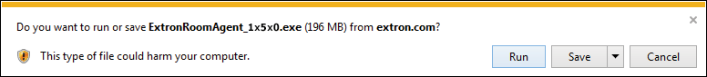

1

###### Figure 9. Download Warning and Confirmation

**NOTE:** Figure 9 may appear different or may not appear at all, depending on your Web browser choice and its security settings.

1. Follow the on-screen instructions. By default, the installation creates the following folder and group folder. It places the entries shown below into correct group folders and on the PC desktop:
   * **Folder** — C:\Program Files\Schedule Depo\Schedule Depo Deposition Scheduler

**NOTE:** C:\Program Files(x86)\... for 64-bit Windows OS.

* + **Group folder** — Schedule Depo Electronics\Schedule Depo Deposition Scheduler

###### Deposition Scheduler Help

* + - **Deposition Scheduler Quick Help**

###### Deposition Scheduler

* + - **Uninstall Deposition Scheduler**

## Configuration

Before you start the Deposition Scheduler software:

1. Ensure all the panels have been mounted and are connected to the network.
2. Ensure you know whether Microsoft Exchange or Office 365 is to be the calendar server and the network location of the server.
3. Ensure that you know the IP addresses of all the panels in the system (especially those that are not on the same subnet as the control PC).
4. Ensure that you know the passwords for all the panels. By default, the password is "Depo". If the passwords have not already been changed, you should do so during configuration.

### Start the Program

Start the Schedule Depo Deposition Scheduler software by double-clicking the desktop icon or as follows:

* 1. Click **Start > All Programs > Schedule Depo Electronics > Schedule Depo Deposition Scheduler > Schedule Depo Deposition Scheduler**.

The Deposition Scheduler software opens in the Panel Management view (the **Panel Management** tab selected.

**Automatically Discover Panels**

Automatically discover panels that are on the same subnet as the computer running the Deposition Scheduler software as follows:

**NOTE:** Any panels not on the same subnet as the computer running Deposition Scheduler must be added using the Manually Add Panels pane (see “Manually Add Panels”).

1. If Panel Management view is not currently displayed, click the **Panel Management** tab.
2. Click the **Discover** button above the Auto Discovered Panels pane (see **figure 10**,

1 on the previous page).

The **Discover** button becomes the **Stop Discovery** button. Panels that are located on the same subnet are automatically discovered and displayed (see figure 11).



1

###### Figure 11. Auto Discovered Panels Pane

1. When all of the panels are displayed, click the **Stop Discovery** button to end the search (see figure 11, 1).

### Manually Add Panels

Manually add panels that are on a different subnet than the computer running the Deposition Scheduler software as follows:

1. If Panel Management view is not currently displayed, click the **Panel Management** tab.
2. Click the **Add New** button above the Manually Added Panels pane (see **figure 10**, 2). The Add New Panel dialog box opens (see figure 12).

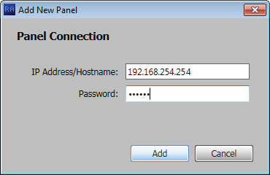

1

2

3

###### Figure 12. Add New Panel Dialog Box

1. Enter the IP address of the desired panel in the IP Address/Hostname: field (see **figure 12**, 1 on the previous page).
2. If the panel is password protected, enter the password in the Password: field (2).

**NOTE:** All panels ship with the default, case-sensitive, password “Depo”.

1. Click the **Add** button (3). Deposition Scheduler searches for the requested panel and, if found, adds it to the Manually Added Panels pane.

### Panel Management Tab

#### Connect to the panel

Each panel requires setup as follows:

1. Click the **Setup** button for the panel to be set up. 



**NOTE:** The button deletes a panel from the list.

The Panel Connection dialog box opens (see figure 14).

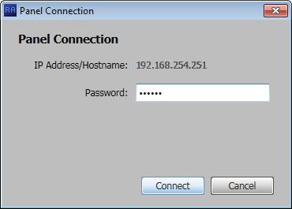

1

2

###### Figure 14. Panel Connection Dialog Box

1. If applicable, enter a password in Password block (see figure 14, 1).

**NOTE:** All panels ship with the default, case-sensitive, password “extron”.

1. Click the **Connect** button (2).

The Deposition Scheduler connects to and synchronizes with the panel. Once synced, Deposition Scheduler displays the Device Management window with either the Communication Settings tab (see **figure 15** on the next page) or General Settings tab (see **figure 16** on page 20) selected.

#### Communication Settings window

The **Communication Settings** tab on the Device Management window (see figure 15) provides a set of tools for managing the following internet settings of the connected panel:

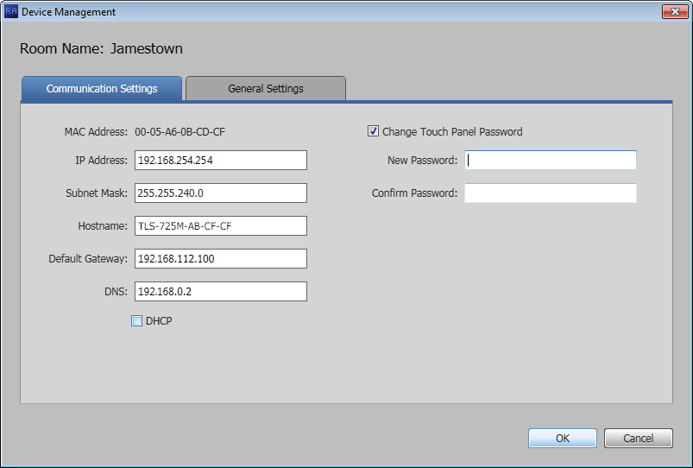

¤¤

1

2

3

4

5

6

8

9

¢

7

£

###### Figure 15. Device Management Window, Communications Settings

1. MAC Address (displayed only) 5 **Default Gateway**
2. **IP Address** 6 **DNS** (Domain Name System) server
3. **Subnet Mask** 7 **DHCP** (Dynamic Host Configuration Protocol)
4. **Hostname**

When the **DHCP** checkbox (see figure 15, 7) is selected, only the **Hostname** can be edited. All other settings (other than DHCP itself) are displayed only and unavailable for editing. To edit all settings (other than the MAC address), **DHCP** must be deselected (unchecked).

**NOTE:** If you configure the panels with a static IP address and you use a host name for the exchange server, ensure that you provide the DNS server address.

**NOTE:** All panels ship with the default, case-sensitive, password “Depo”. Schedule Depo recommends that you change the password.

The **Communication Settings** tab also allows users to change the password of the panel.

Change the password as follows:

1. Click (select) the **Change Touch Panel Password** checkbox (8).
2. Enter the new password in the **Password** (9) and **Confirm Password** (¢) fields. Once you have made all desired changes available from the **Communication Settings**

tab, click the **OK** button.

#### General Settings window

The **General Settings** tab on the Device Management window (see figure 16) provides a set of tools for managing display, time, and audio settings of the connected panel.

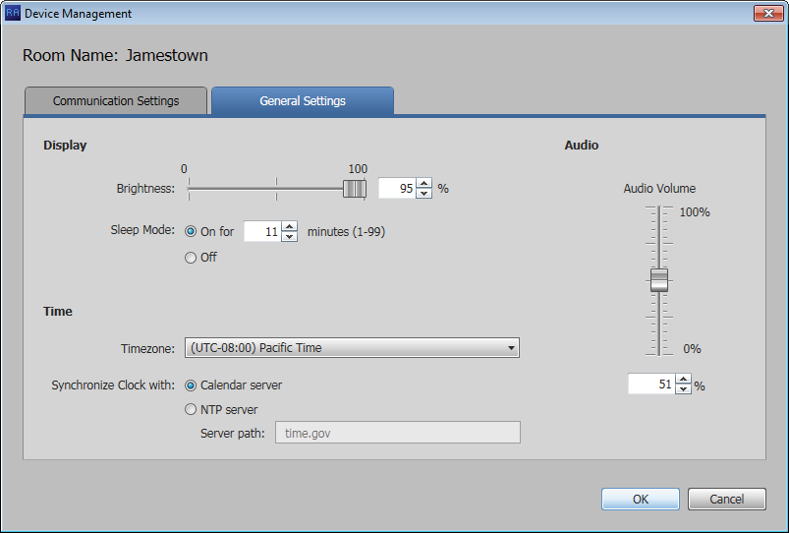

8

1

2

6

3

4

5

7

###### Figure 16. Device Management Window, General Settings

1. **Display Brightness** — Set the panel illumination brightness, from **0** to **100** (percent) using this fader control.
2. **Display Sleep Mode** — Toggle Sleep mode **On** and **Off** by selecting the appropriate radio button. If Sleep mode is **On**, use the Minutes field to specify between **1** and **99** minutes.
3. **Timezone** — Use the drop-down list to select the appropriate time zone.
4. **Synchronize Clock with** — Toggle the clock synchronization source between the **Calendar server** and **NTP** (Network Time Protocol — a networking protocol for clock synchronization between computer systems) by selecting the appropriate radio button.

**NOTE:** If you select **NTP**, specify the path to the NTP server in the Server path:

field (5).

1. **Server path:** (available only if NTP is selected in 4) — Specify a path for the NTP server.
2. **Audio Volume** — Set the panel audio volume, from **0** to **100** (percent) using this fader control.

Once you have made all desired changes available from the **General Settings** tab, click either the **OK** button (7, the Device Management window closes) or the **Communication Settings** tab (8, then communication settings are displayed, see **figure 15** on the previous page).

### Panel Configuration Tab

The Panel Configuration window provides a set of tools for selecting among the supported calendar servers and managing the settings of the selected server.

**NOTE:** Until you designate the calendar server for your system, only the **Select a Calendar Type** drop-down list is available for selection.

Click the **Select a Calendar Type** drop-down list and select among the choices shown in figure 17. The appearance and available selections of the Panel Configuration tab vary depending on the selection:

The function of the **Configuration** and **Activity** buttons is common to all Calendar Type selections. See **Common Panel Configuration tab functions** on page 35. For all other functions on these windows:

* If you selected **Microsoft® Exchange™**, see **Exchange configuration** on the next page.
* If you selected **Microsoft® Office 365™**, see **Office 365 configuration** on page 28.

**Exchange** **configuration**

When you select **Microsoft® Exchange™,** the Panel Configuration window displays the settings necessary to connect to the panels and configure them for Microsoft Exchange (you may also commonly hear this referred to as “Exchange On Premises” or “on Prem”) .

***Connect to the server***

Connect to the Microsoft Exchange server as follows (see figure 19):



**2**

1

3

4

###### Figure 19. Establishing a Connection the Microsoft Exchange Server

1. If necessary, click the **Protocol** drop-down list and select between **https://** and

**http://** (see figure 19, 1).

**NOTE: https://** is the correct selection for virtually all applications.

1. Click the **Discover Server** button (2). The Auto Discover Microsoft Exchange Server dialog box opens (see figure 20).

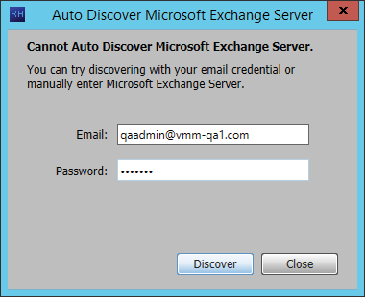

1

2

3

###### Figure 20. Auto Discover Dialog Box

1. Enter your **Email** credentials (see **figure 20**, 1 on the previous page) and the

**Password** (2).

1. Click the **Discover** button (**figure 20**, 3). Deposition Scheduler finds the calendar server and fills in the **Server** field (see **figure 19**, 3 on the previous page). Deposition Scheduler is connected to the server.
2. **If necessary**, change the **SSL Certificate** drop-down list selection (**figure 19**, 4):
   * **Trusted CA Signed SSL Certificate** — Directs Deposition Scheduler to validate that certificates are signed by one or more trusted Certificate Authorities. **This is the correct selection for most applications.**
   * **No Verification of SSL Certificate** — Bypasses the validation. Use this selection if the connecting Exchange server is using self-signed SSL certificates.

**NOTE:** Consult the Exchange administrator for the connecting server if you are unsure about which is the correct selection.

##### *Configure panels*

Configure the panels for Exchange as follows (see figure 21):

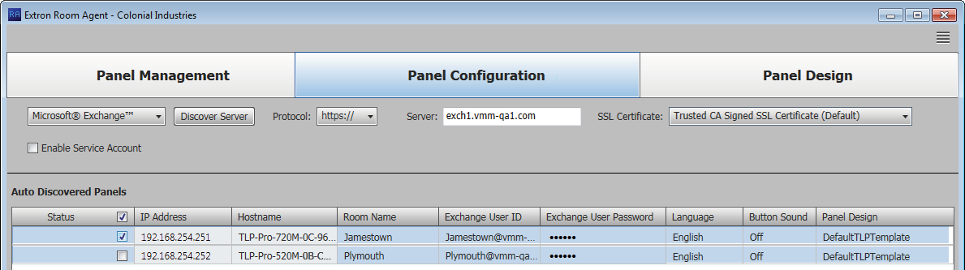

1

3

4

5

6

7

8

2

###### Figure 21. Panel Configuration

**NOTE:** The **Enable Service Account** checkbox (see figure 21, 1) allows one or more service accounts to be used to configure the panels. See **Use service accounts**beginning on the next page to configure and use service accounts.

1. Select (check) one or more **Status** checkboxes (2).
2. For the direct entry settings, **Room Name** (3), **Exchange User ID**

(Exchange credentials, 4), and **Exchange User Password** (5):

**NOTES:**

* If service accounts are enabled, the **Exchange User ID** and **Exchange User Password** columns are titled **Service Account** and **Room Resource Account** (see **figure 22** on the next page).
* The **Exchange User ID** requires the User Principal Name (UPN, the name of a Windows network user in an e-mail address format) for the room resource user ID. The UPN **must** have an SMTP e-mail address assigned to it.
  1. Click in the desired field.
  2. Type the desired value.
  3. Type the keyboard <**Tab**> key to exit the field.

1. For the drop-down lists, **Language** (see **figure 21**, 6 on the previous page), **Button Sound** (7), and **Panel Design** (8):

**NOTES:**

* The **Language** menu includes a number of different languages. See **Supported****Languages** on page 62 for a complete list.
* The **Button Sound** menu consists of **On** and **Off**.
* The **Panel Design** menu includes the **DefaultTLPTemplate**, which is the default that is installed as part of the Deposition Scheduler software, as well as any templates that you have created and saved (see **Templates pane** on page 44).
  1. Click in the desired field.
  2. Click the drop-down list button ( ).
  3. Click the desired setting.

***Use service*** ***accounts***

The Deposition Scheduler software can use the service account functions of the Exchange and Office 365 "impersonation" feature as a single point to manage the configuration of multiple panels. One example of this application is a facility where passwords are changed every few months; rather than change the password on multiple panels, an administrator can change the password of one service account tied to multiple panels.

**Enable and add** **service accounts —**

1. If necessary, access the Exchange server Active Directory Users and Computers window or the Office 365 Admin center page and create one or more service accounts with valid e- mail addresses.

**NOTE:** The service account requires the UPN, the name of a Windows network user in an e-mail address format. The UPN **must** have an SMTP e-mail address assigned to it.

1. On the Deposition Scheduler software Panel Configuration page, select the **Enable Service Account** checkbox (see figure 22, 1). The **Service Account Manager** button appears (2). The **Exchange User ID** and **Exchange User Password** columns become **Service Account** (3) and **Room Resource Account** (4).

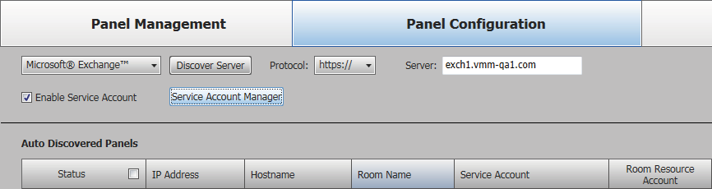

1

2

3

4

**Figure 22. Enable Service Accounts**

**NOTE:** Figure 22 shows **Microsoft® Exchange™** selected. With the exception of the selection, the appearance is identical when **Microsoft® Office 365™** is selected.

1. Click the **Service Account Manager** button (see **figure 22**, 2 on the previous page). The Service Account Manager dialog box opens with the **Assign Service Account** tab selected (see figure 23, 1).

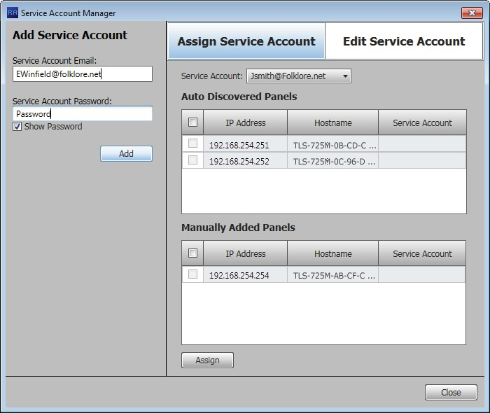

2

1

6

3

4

5

###### Figure 23. Add Service Accounts

1. Enter a valid **Service Account Email** address (2).
2. Enter the **Service Account Password** (3).

**TIP:** The **Service Account Password** field is normally masked (•••). Select the

**Show Password** checkbox (4) to see the password characters as you type.

1. Click **Add** (5). The Add Service Account area displays the message Service Account has been added and is ready to be assigned to panels. The account is added to the **Service Account** drop-down list (6).
2. Repeat steps 4 through 6 for each service account.

###### Assign service accounts —

1. If necessary, click the **Assign Service Account** tab (see figure 24, 1).

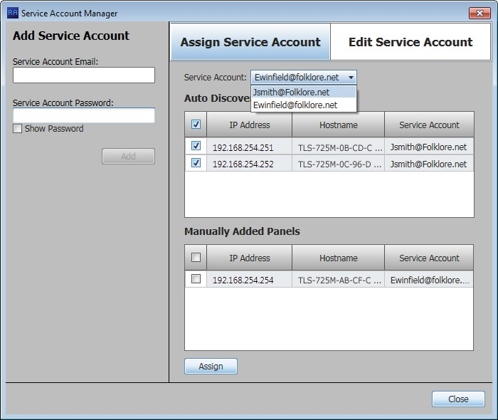

1

4

3

2

6

5

7

###### Figure 24. Assign Service Accounts

1. Select (check) one or more panel **IP Address** checkboxes (2).

**TIP:** Select either the **Auto Discovered Panels** or **Manually Entered Panels**

checkbox (3) to select all panels in that pane.

1. Select the desired service account among the entries in the **Service Account**

drop-down list (4).

1. Click **Assign** (5). The selected Service Account is assigned to the designated panels (6).
2. Repeat steps 2 through 4 to assign other service accounts to other panels.
3. Click **Close** (7). The Service Account Manager dialog box closes and the Deposition Scheduler software returns to the Panel Configuration Window displayed. For the panels with service accounts that are enabled, the normal **Exchange User ID** and **Exchange User Password** columns are titled **Service Account** and **Room Resource Account** (see figure 25).

**Service Accounts Not Enabled**

**Service Accounts Enabled**



1

###### Figure 25. Display With Service Accounts Enabled and Not Enabled

1. For each panel, enter the e-mail address used as the fully qualified room resource in the

**Room Resource Account** column (see figure 25, 1).

###### Edit a service account password —

1. Figure 26. Edit Passwords

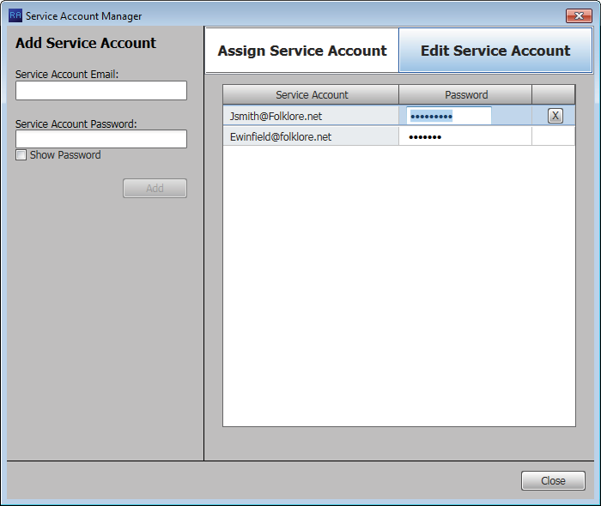

1

5

**2**

3

6

4

1. Double-click in the **Password** field for the service account to be edited (2).
2. Highlight the password and type a new value (3).
3. Type the keyboard <**Enter**> key.



**TIPS:**

* The **Password** field is normally masked (•••). Delete the existing password to activate the Show feature to see the password characters

as you type.

* Click **Show** to toggle between **Show** and **Hide**.
* After you type <**Enter**>, the **Password** field is again masked.

1. Click **Close** (4).

###### Delete a service account password —

1. If necessary, open the Service Account Manager dialog box (see **Enable and add****service accounts**, steps 2 and 3, beginning on page 24).
2. Click the **Edit Service Account** tab (see figure 26, 1).
3. Double-click in the **Password** field for the service account to be deleted (2).
4. Select (click) a service account (5).
5. Click **Delete** ( ) button (6).
6. Click **Close** (4).

#### Office 365 configuration

When you select **Microsoft® Office 365™** (see **figure 17**, 1 on page 21), the Panel Configuration window displays the settings necessary to configure the panels for Microsoft Office 365 (see figure 27).

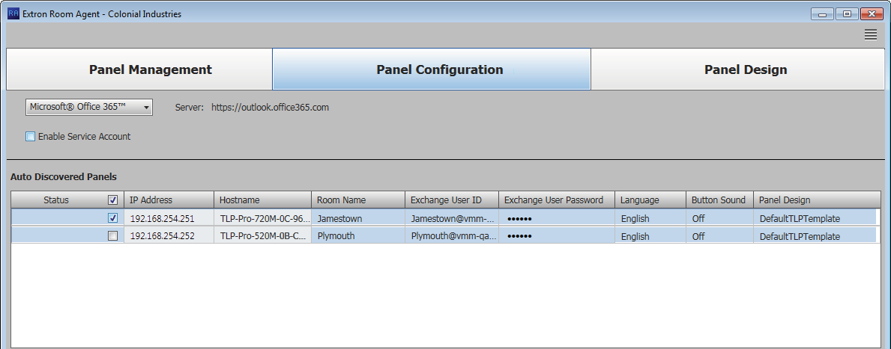

1

3

4

5

6

7

8

2

**Figure 27. Panel Configuration Window, Office 365 View**

**NOTE:** The **Enable Service Account** checkbox (see figure 27, 1) allows one or more service accounts to be used to configure the panels. See **Use service accounts**beginning on page 24 to configure and use service accounts.

***Connect to the server***

Connection to the panels is made automatically, through the Office 365 server.

##### *Configure panels*

Configure the panels for Office 365 as follows:

1. Select (check) one or more **Status** checkboxes (see figure 27, 2).
2. For the direct entry settings, **Room Name** (3), **Exchange User ID** (Exchange credentials,

4), and **Exchange User Password** (5):

**NOTES:**

* If service accounts are enabled, the **Exchange User ID** and **Exchange User Password** columns are titled **Service Account** and **Room Resource Account**.
* The **Exchange User ID** requires the User Principal Name (UPN, the name of a Windows network user in an e-mail address format) for the room resource user ID. The UPN **must** have an SMTP e-mail address assigned to it.

1. Click in the desired field.
2. Type the desired value.
3. Type the keyboard <**Tab**> key to exit the field.
4. For the drop-down lists, **Language** (see **figure 27**, 6 on the previous page), **Button Sound** (7), and **Panel Design** (8):

**NOTES:**

* The **Language** menu includes a number of different languages. See **Supported****Languages** on page 62 for a complete list.
* The **Button Sound** menu consists of **On** and **Off**.
* The **Panel Design** menu includes the **DefaultTLPTemplate**, which is the default that is installed as part of the Deposition Scheduler installation, as well as any templates that you have created and saved (see **Templates pane** on page 44).
  1. Click in the desired field.
  2. Click the drop-down list button ( ).
  3. Click the desired setting.

#### Common Panel Configuration tab functions

##### *Send and retrieve* *the configuration*

The send and receive configuration functions push and pull configurable settings between the Deposition Scheduler software and one or more panels.

Send or receive one or more configurations as follows:

1. Select (check) one or more **Status** checkboxes.
2. Click the **Send Configuration** button to send the Deposition Scheduler settings to the panels and implement them in the panels.

###### — or —

Click the **Retrieve Configuration** button to fetch configurable settings from one or more panels and embed them in the Room

Agent settings and fields.



**TIP:** Or, easily retrieve the configuration for a single panel by right-clicking the panel in the Status column and then clicking the

pop-up **Retrieve Configuration** button.

The Deposition Scheduler software reports that the Status is in progress ( ) and then reports either Config Sent. or Config Retrieved.

##### *Retrieve and clear the activity file*

Each panel maintains an activity file, a log of scheduling information; such as the meeting subject, meeting organizer, booking date, meeting date and starting time, and duration; among other data for the assigned room. The activity file can be retrieved and written to the PC running the Deposition Scheduler software as an Microsoft Excel spreadsheet or cleared (erased) from the panel. You can use data analytics tools to transform this activity data to create usage reports.

**NOTE:** The panel has 4 Mb of activity file memory. The number of entries varies depending on the size of each entry, but may number in the hundreds. When the memory becomes full, the newest entries overwrite the oldest. There is **no** notification when the memory becomes full.

Retrieve or clear one or more activity files as follows:

1. Select (check) one or more **Status** checkboxes.
2. Click the **Retrieve Activity File** button to fetch the schedule log and from one or more panels and save it in a spreadsheet. The

Deposition Scheduler software opens the Panel Activity File dialog box (see figure 36).

###### Proceed to step 4.

**— or —**

Click the **Clear Activity File** button to erase the schedule log from one or more panels.

**For the clear operation**, the Deposition Scheduler software reports that the Status is in progress ( ) and then reports Cleared. and All panel activity logs have been cleared successfuly.

1. Click **OK** to exit the clear operation.
2. Enter a name for the retrieved activity file (see figure 36, 1).

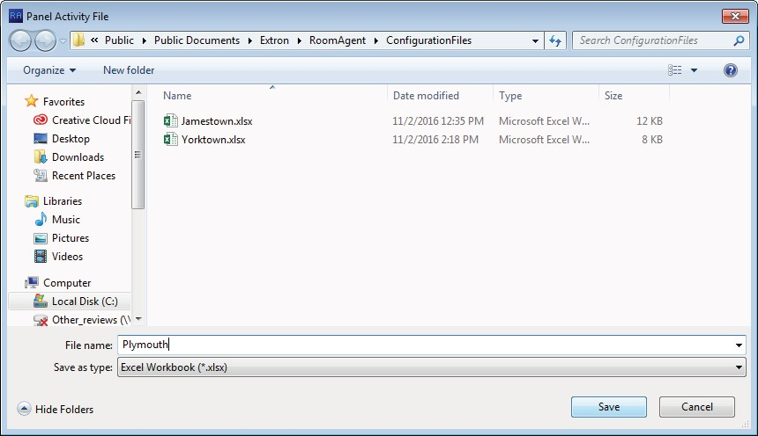

1

2

###### Figure 36. Panel Activity File

1. Click **Save** (2). The Deposition Scheduler software saves the file. It reports that the Status is in progress ( ) and then reports Activity retrieved. and All activities have been retrieved successfully.

##### *Retrieve a template*

Templates allow you to create a number of customized panel appearances. Templates are selectable using the **Panel Design** menu in the Panel Configuration window (see

**figure 21**, 7 on page 22 for an example). Templates can be created using a variety of tools in the Panel Design window (see **Panel Configuration Tab** on page 21) and saved in the

template pane (see **Templates pane** on page 44).

You can retrieve the template assigned to a panel, for example to use as a starting point for designing a new panel layout, as follows:

1. Right-click the panel in the Status column see 1, at right).



1

2

1. Click the pop-up **Retrieve Template for**

**Design** button (2). The Retrieve Template dialog box opens (see figure 37).

(see

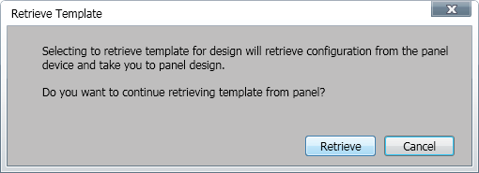

1

###### Figure 37. Retrieve Template Dialog Box

1. Click **Retrieve** (see figure 37, 1). Deposition Scheduler software displays the Retrieving Template **...** activity indicator while it loads the template and then automatically jumps to the Panel Design window

### Panel Design Tab

The Panel Design window (see figure 38) provides tools for customizing the appearance and function of the connected panels. The window consists of the design pane (1, see "Design pane"), the preview pane (2, see **Preview pane** on page 44), and the Templates pane (3, see **Templates pane** on page 44).

**NOTE:** The preview pane contains hardcoded, **sample**, entries. The layout and appearance of this pane change to reflect changes in the design pane, but, other than the date and time, the contents, such as “Main Conference Room”, do not change.

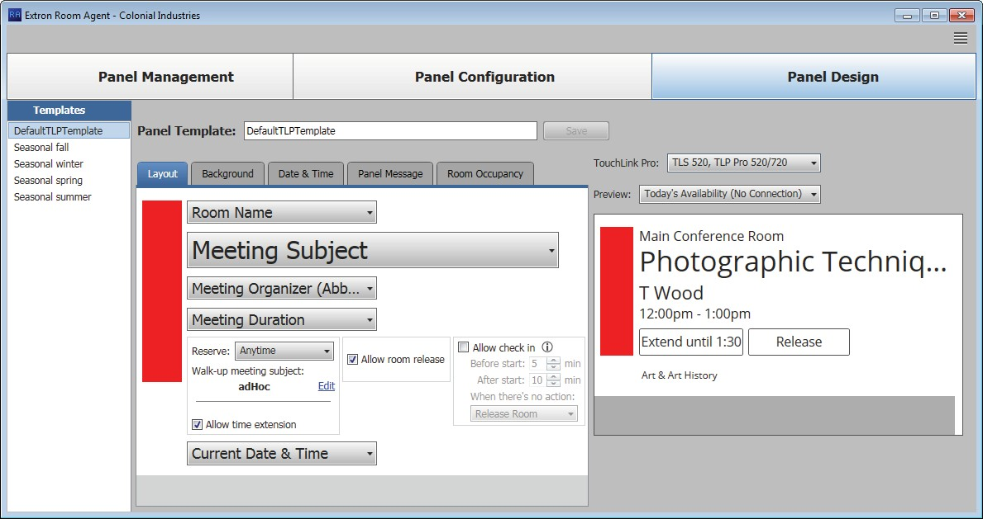

3

1

2

**Figure 38. Panel Design Window, Layout Tab Selected**

**Design pane**

##### *Layout tab*

If necessary, click the **Layout** tab (see **figure 39**, 1 on the next page) to make changes to the following:

* The arrangement of the fields on the display
* Whether or not you can locally (on the panel):
  + Reserve the room
  + Release the room
  + Extend the meeting time



|  |  |  |
| --- | --- | --- |
| 2 |  | |
| 2 |  |  |
| 2 |  |  |
| 2 |  |  |
| 3 | 4 | 5 |

###### Figure 39. Panel Design Pane, Layout Tab

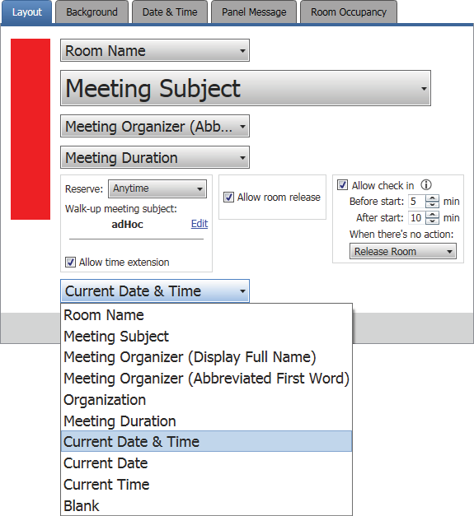

1

Ü Ý

ê

ë

2

Õ

1. **Data field drop-down lists** — These five menus are positioned within the pane to correspond to data positions on the panels and in the preview pane (see **figure 38**, 2 on the previous page). All menus contain the same options (see figure 39, Õ). Select among the options to choose the data displayed in the corresponding position. Watch the preview pane to see how your selections affect the appearance of a panel. Selecting **Blank** causes no data in the associated position.

**NOTE: Organization** is available for selection only when you have selected **CollegeNET 25Live** on the Panel Management page (see **figure 17**, 1 on page 21). **Organization** causes the panel to display the organization associated with the booked meeting, such as Arts & Art History in the preview pane.

1. **Reserve: drop-down list** — Use this drop-down list to select whether the **Reserve** button appears on the panel and how it functions. The **Reserve** button allows user to book the room locally, on the panel itself. **Anytime** allows you to reserve any half-hour segment displayed on the panel.

Ü **Subject field** (see figure 39) — This field shows the meeting subject displayed on the panel when a room is reserved from the panel. “adHoc” is the default subject. Change the meeting subject as follows:

* 1. Click the **Edit** link (see figure 40, 1).

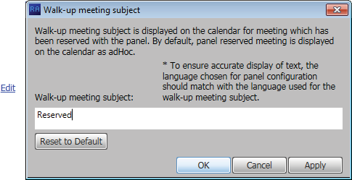

1

2

3

###### Figure 40. Walk-up Meeting Subject Dialog Box

* 1. Type the new subject name in the Walk-up meeting subject: field (2).
  2. Click **OK** (3).

Ý **Allow time extension checkbox** — Check and uncheck this box to select whether the **Extend until** button appears on the

panel. **Extend until** extends the reservation of a room in half-hour increments **IF** no previously scheduled reservation exists in the extension period. The **Extend until** button does not appear if there is a conflict.

1. **Allow room release checkbox** — Check and uncheck this box to select whether the **Release** button appears on the panel. **Release** frees up a room, for example if the meeting ends early.
2. **Allow check in checkbox** — Check and uncheck this box to select whether the **Check in** button appears on the panel for a scheduled meeting. **Check in** disappears from a panel once it is pressed.

If checked, additional controls (ê and ë) appear on the panel to control how the

**Check in** button functions.

ê **Before start and After start fields** — Use the scroll buttons or type a value into these fields to define how long the **Check in** button appears.

* **Before start:** controls how many minutes the **Check in** button displays before the scheduled start of a meeting.
* **After start:** controls how many minutes the **Check in** button appears after the scheduled start of the meeting.

ë **When there’s no action drop-down list** — Select among the options to choose how the **Check in** button and room reservation behave when no action is taken.

* **Release room** — The scheduling software releases the room when the **After start:** time has expired.
* **Hide check in** — The scheduling software hides the **Check in** button on the panel and releases the room when the **After start:** time has expired.
* **Do not hide check in** — The panel continues to display the **Check in** button until it is pressed.

##### *Background tab*

If necessary, click the **Background** tab (see figure 41, 1) to make changes to the following:

* The color theme (dark or light) of the panel display:
* Any background image
* The opacity of any background image

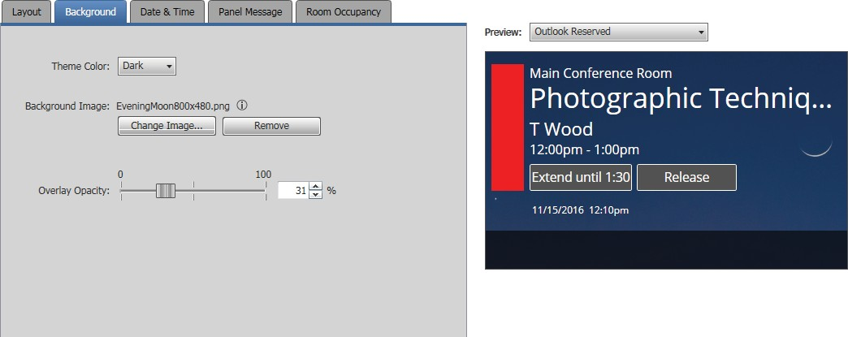

1

2

3

4

###### Figure 41. Panel Design Pane, Background Tab and Preview Pane

1. **Theme color: drop-down list** — Use this drop-down list to

select either **Light** (black text on a light background) or **Dark** (white

text on a dark background).

###### Background image: —

* + **Change Image... button** — Click to open a dialog box to assign a background image (see figure 42 and the following procedure).
  + **Remove button** — Click to clear any assigned background image.

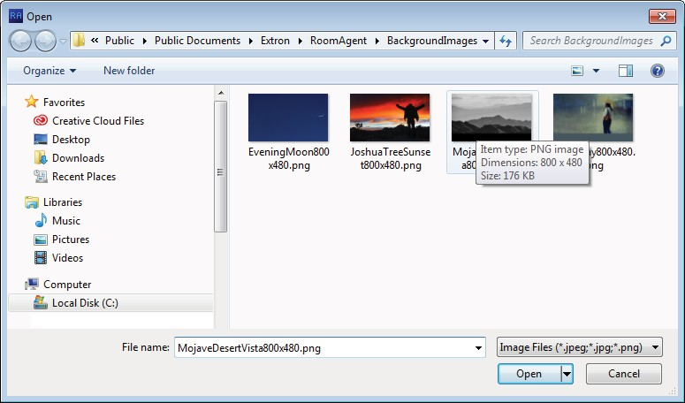

1

1

2

###### Figure 42. Open Dialog Box and Assign a Background Image

Assign or change a background image as follows:

**NOTE:** Deposition Scheduler software and the scheduling system support image files with the following traits only:

* JPEG or PNG format
* 800x480 resolution
* 8-bit color

1. Click the **Change Image...** button (see **figure 41**, 3 on the previous page). The

Open dialog box opens.

1. Navigate to the folder where you saved the background image file. Select the file (see **figure 42**, 1 on the previous page).
2. Click **Open** (2). The Open dialog box closes and the newly assigned background image is displayed in the preview pane (see **figure 41**).
3. **Overlay Opacity** (see **figure 41**) —Click and drag this fader control or type a value

directly in the field to set the opacity of any displayed background image.

##### *Date & Time tab*

If necessary, click the **Date & Time** tab (see figure 43, 1) to make changes to the date and time format.

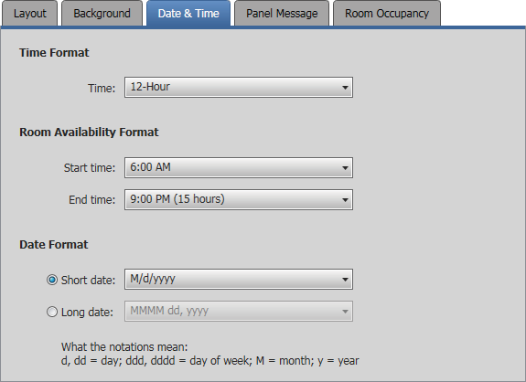

1

2

3

4

5

6

7

###### Figure 43. Panel Design Pane, Date & Time Tab

1. **Time Format, Time: drop-down list** — Use this drop-down list to select among

**12-Hour** (1:30 PM, for example), **24-Hour US** (13:30),and **24-Hour International**

(13.30).

1. **Room Availability Format, Start time: drop-down list** — Use this drop-down list to select the start time of room availability display, in half-hour increments.
2. **Room Availability Format, End time: drop-down list** — Use this drop-down list to select the end time of room availability display, in half-hour increments. The menu also shows the quantity of time the room availability is displayed.
3. **Date Format radio buttons** — Use these radio buttons to select the format to display on the panel. After you select either **Short date** or **Long date**, the associated drop- down list (see 6 and 7 on the next page) becomes available for selection.
4. **Short date: dr****op-down list** — Use this drop-down list, available when the **Short date** radio button is selected, to select among short date (in which the month is represented by a numeral) display formats.
5. **Long date: dr****op-down list** — Use this drop-down list, available when the **Long date** radio button is selected, to select among long date (in which the month is spelled out) display formats, such as day month year or month day year and whether to include the day of the week.

##### *Panel Message tab*

If necessary, click the **Panel Message** tab (see figure 44, 1) to make changes to the message displayed when the panel has no connection to the calendar server.

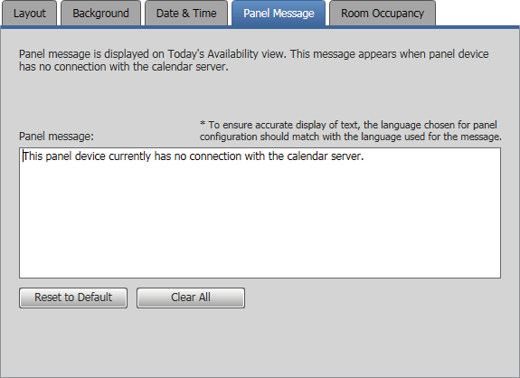

1

2

**3**

**4**

###### Figure 44. Panel Design Pane, Panel Message Tab

1. **Panel message: field** — Type in the panel message to be displayed.
2. **Reset to Default button** — Click to return the default panel message (displayed in figure 44).
3. **Clear All button** — Click to clear the panel message.

##### *Room Occupancy tab*

**NOTES:**

* This screen is always selectable and behaves as described, but only TLS 520M, TLS 725M, and TLS 1025M scheduling panels, and TLP Pro 520M touch panels have the digital I/O connectors necessary to connect the OCS 100 Occupancy Sensors.
* See **Occupancy Sensor Configuration** on page 63 for an overview of connecting the occupancy sensors to compatible panels.

If necessary, click the **Room Occupancy** tab (see figure 45, 1) to access the settings for rooms equipped with occupancy sensors.

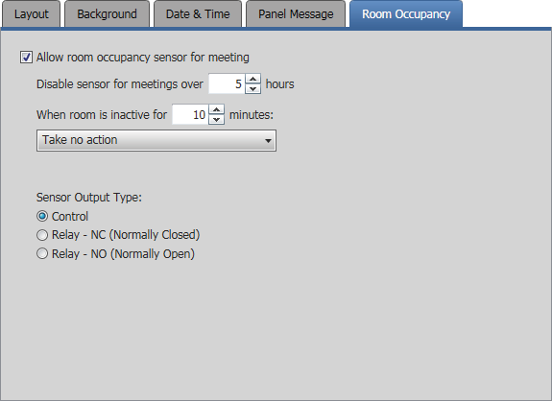

1

2

Õ Ö

×

3

###### Figure 45. Panel Design Pane, Room Occupancy Tab

1. **Allow room occupancy sensor for meeting checkbox** — Check and uncheck this box to enable and disable the use of room occupancy sensors to determine if a meeting has started.

If checked, additional controls (see Õ through ×) become available to control how the sensors function.

Õ **Disable sensor field** — Use the scroll buttons or type a value into this field to disable the sensors for longer meetings.

Ö **When room is inactive field** — Use the scroll buttons or type a value into this field to set a time of room inactivity after the scheduled start time, after which the room **may** be released for another meeting (as defined in ×). This field may not contain

**0** minutes.

**NOTE:** This counter begins after the sensor has changed state to indicate the room is unoccupied.

× **When room is inactive drop-down list** — Use this drop-down list to select between **Take no action** (leave the room reserved) and **Release room** (make the room available for other users).

1. **Sensor Output Type radio button** (see **figure 45** on the previous page) — Select one of these radio buttons to denote how the occupancy sensor is wired to the TLS 520M, TLS 725M, or TLS 1025M scheduling panel or TLP Pro 520M touchpanel:
   * **Control**
   * **Relay - NC (Normally Closed)**
   * **Relay - NO (Normally Open)**

#### Preview pane

The preview pane (see figure 46, 1) shows the effects of changes that you make using the controls within the panel design pane.

**NOTE:** The preview pane contains hardcoded, **sample**, entries. The layout and appearance of this pane change to reflect your changes in the design pane, but, other than the date and time, the content, such as “Main Conference Room”, do not change.

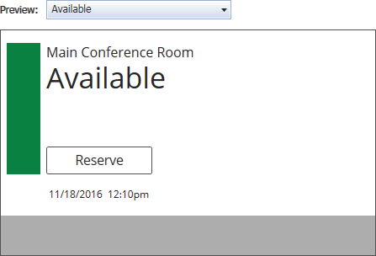

2

1

###### Figure 46. Preview Pane and Drop-down list

2 **Preview: drop-down list** — The **Preview:**

drop-down list lets you select among various

display possibilities so that you can further refine the appearance of panels in all of these circumstances.

#### Templates pane

Templates, such as the default **DefaultTLPTemplate**, which is the default that is installed as part of the Deposition Scheduler installation, allow you to create a number of customized panel appearances. Each panel in a system can have its own template, assigned on the Panel Configuration window (see **figure 21**, 7 on page 22 for an example). Select the templates on the Templates pane (see figure 47).

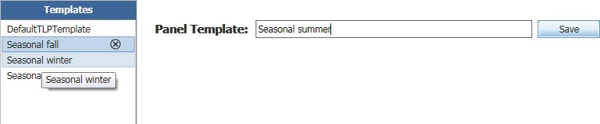

3

4

1

2

###### Figure 47. Templates Pane and Drop-down list

* To assign the appearance of a displayed template to the panels, double-click a displayed template (1).
* To delete a template, click the (2).
* To add a new template:
  + Type a name in the Panel Template: field (3).
  + Click the **Save** button (4).

## Show Available Network Adapters

Deposition Scheduler can show you all of the network interfaces available on the computer for you to use in communications and allow you to select the active one. Type

<**Ctrl**>+<**Shift**>+<**F2**> to open a dialog box displaying the available controllers (see figure 48).

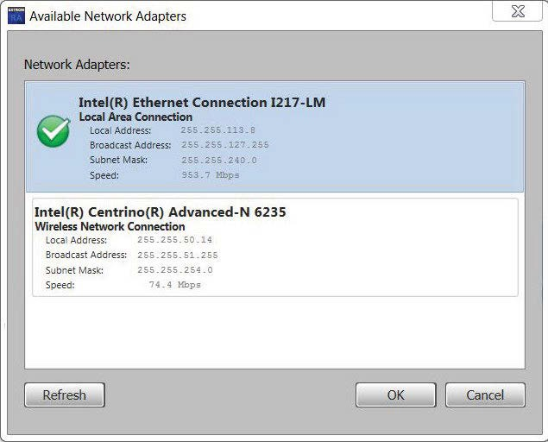

1

4

2

3

###### Figure 48. Available Network Controllers Dialog Box

Select a network controller as follows:

1. Click the desired controller (1).
2. Click **OK** (2).

To close the dialog box without selecting the controller, click **Cancel** (3). To refresh the view, click **Refresh** (4).

## Update Firmware

Deposition Scheduler reports Cannot connect to this device if the panel firmware version is:

* Older than 2.01.0000-b008
* **TLP Pro touchpanel models only** — Is the shipped-from-the-factory firmware (firmware for the panels as part of control systems.

**NOTE:** The latest firmware for all compatible panels is automatically downloaded onto your PC when you install the Deposition Scheduler software. New versions of Deposition Scheduler software may have new firmware that supports new features.

Update panel firmware for any reason as follows:

**NOTE:** Whenever you download a new version of Deposition Scheduler software, you should update firmware to take advantage of the any new features the software provides.

1. Click the **Setup** button for a panel to be updated. 



**NOTE:** The button deletes a panel from the list.

The Panel Connection dialog box opens (see figure 49).



1

2

###### Figure 49. Panel Connection Dialog Box

1. If applicable, enter a password in **Password** field (1).

**NOTE:** All panels ship with the default, case-sensitive, password “extron”.

1. Click the **Connect** button (2).

**NOTE:** This step and this connection are necessary to send a firmware file to the panel.

The Deposition Scheduler software connects to and synchronizes with the panel. Once synced, Deposition Scheduler displays the Device Management window with either the Communication Settings tab (see **figure 15** on page 19) or General Settings tab (see **figure 16** on page 20) selected.

1. Click **OK**. The Device Management window closes and the Panel Configuration window is displayed (see figure 50).

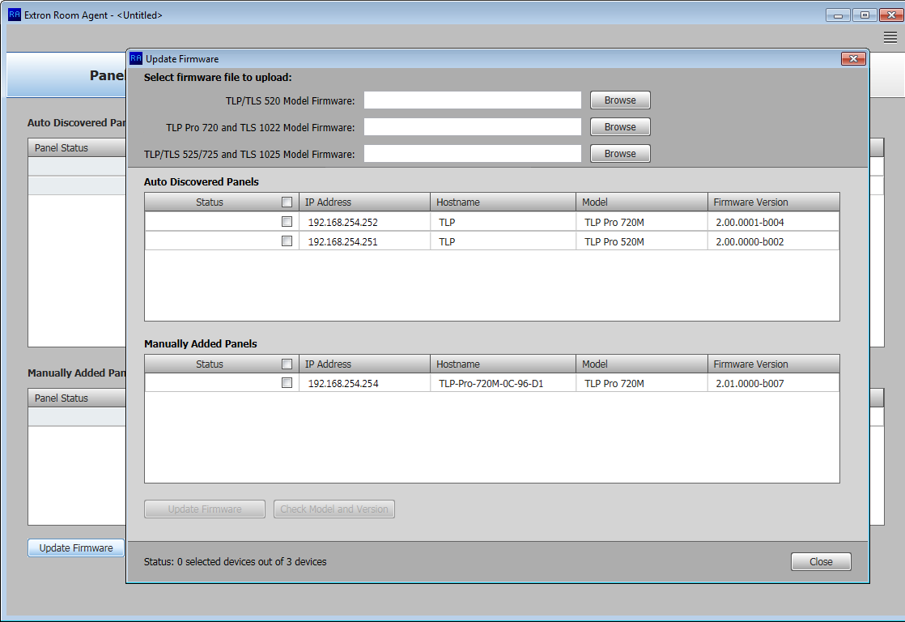

2

3

3

3

1

###### Figure 50. Firmware Update

1. Click the **Update Firmware** button (see figure 50, 1). The Update Firmware window opens (2).
2. Click the **Browse** button for the desired model (3):
   * **TLP/TLS 520 Model Firmware**
   * **TLP Pro 720 and TLS 1022 Model Firmware**
   * **TLP/TLS 525/725 and TLS 1025 Model Firmware**

The Open Firmware File dialog box opens in the appropriate folder for the firmware (see **figure 51** on the next page).

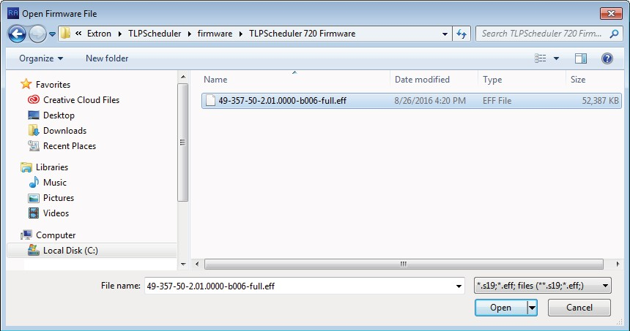

1

2

###### Figure 51. Firmware File Selection

1. Select the file (see figure 51, 1).
2. Click **Open** (2). The Update Firmware window returns to the top with the firmware file selected (see figure 52, 1).

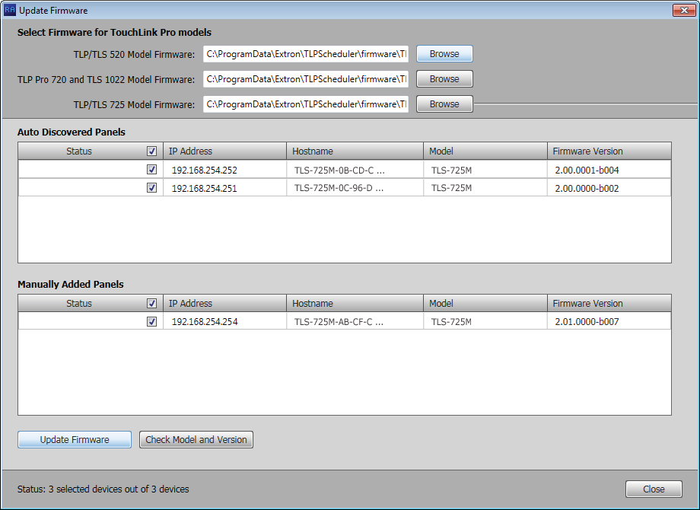

1

2

2

4

3

4

5

###### Figure 52. Selecting Firmware Files and Panels

1. If desired, repeat **steps 2 through 4**, beginning on page 46 for other panel types. The

Update Firmware window returns to the top with the firmware file selected (2).

1. Select (click) one or more checkboxes for the panels that you want to update (see **figure 52**, 3 and 4 on the previous page). Ensure that you have the correct firmware file selected for the panels you select.

Once firmware files and panels are selected, the **Update Firmware** button becomes available for selection (5).

1. Click the **Update Firmware** button (5). The Status column reports the status of the update (see figure 53). When the Status is Updated, the update is complete.

###### Figure 53. Firmware Update Status Flow

1. Click the **Close** button to return to the Panel Management view (see **figure 13** on page 17). Deposition Scheduler reports Panel Info Updated in the Panel Status column.

# Microsoft Environment Setup

This section provides guidance for an experienced IT person to set up the Room Scheduling System in a Microsoft environment (Office 365 and Exchange). Topics include:

###### Platform Versions

###### Before You Begin

###### Set up the Room Scheduling System in the Microsoft Environment

The Schedule Depo Room Scheduling System works within the Microsoft environment (Exchange and Office 365) by tying compatible panels to room mailboxes. This tie allows Microsoft Outlook users to view the availability of a room and reserve it. This section guides system administrators through linking the Scheduling System to the Rooms.

**Platform Versions**

The Schedule Depo Room Scheduling System works with cloud-based Microsoft Office 365 as well as the following Microsoft Exchange versions maintained on the premises of your facility:

* Exchange 2007, Service Pack 1
* Exchange 2010
* Exchange 2013
* Exchange 2016

In Exchange servers, the Room Scheduling System uses the Exchange Web Services (EWS) protocol to tie in to the server room mailboxes; no plugins or additional software are required on the server.

The Room Scheduling System subscribes to the room mailboxes. The EWS protocol includes push notifications. The server pushes change notifications to the Room Scheduling System whenever calendar changes occur.

## Before You Begin

Complete all of the following steps before starting to set up the Room Scheduling System:

* Ensure all of the desired panels are installed in the appropriate locations (see **Panel****Installation Overview**, beginning on page 64).
* Ensure that all rooms are listed in the Exchange server (Exchange on premises) or Exchange online (Office 365).
* Compile a list of the following for all panels designated as room scheduling devices and all rooms.
  + **Panel IP addresses** — Each panel in the system requires a unique IP address.

The default address for all compatible panels is 192.168.254.251.

Visit **www.ScheduleDepo.com** and see the applicable panel user guides, to assign unique IP addresses to each panel.

* + **Panel passwords** — All panels ship with the default, case-sensitive, password “Depo.” See the applicable manuals listed above to assign different passwords.
  + **Exchange User IDs** — The Exchange User ID requires the User Principal Name (UPN, the name of a Windows network user in an SMTP e-mail address format) for the room resource user ID. The UPN **must** have an SMTP e-mail address assigned to it.
    - Abbreviated Exchange User IDs (aliases) will not work.
    - See **Verify the Exchange User ID is the UPN (Exchange)**  or **Verify the Exchange User ID is the UPN (Office 365)**  if you are not certain that your Exchange User IDs are UPNs.
  + **Room passwords**

### Verify the Exchange User ID is the UPN (Exchange)

**NOTE:** The guidelines in this section are intended for IT professionals only. Installers or integrators attempting to follow these guidelines should do so only in close coordination with the IT department of the organization where the Room Scheduling System is to be installed.

Verify the UPN as follows:

1. Access the Exchange server Active Directory Users and Computers window (see figure 54).

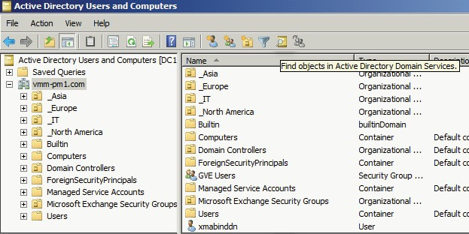

1

###### Figure 54. Active Directory

1. Click the **Find object** ( ) icon (see figure 54, 1). The Find Users, Contacts, and Groups dialog box opens (see figure 55).

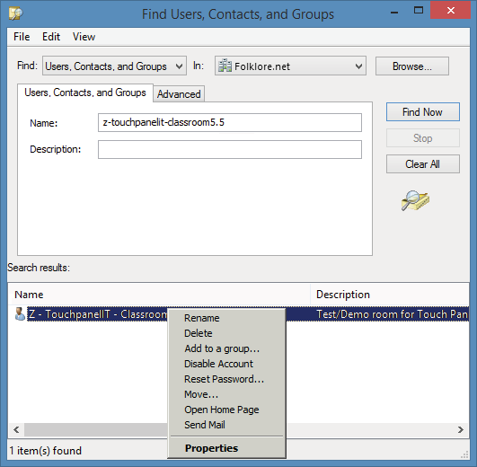

1

2

**3**

4

5

###### Figure 55. Find Users, Contacts, and Groups Dialog Box

1. Enter the name of the room to be verified in the User, Contacts, and Groups **Name**

field (1).

1. Click **Find Now** (2). The Search results: pane displays the room (3).
2. <Right-click> the room in the Search results: pane (4) and click **Properties** (5).

The Properties dialog box opens (see figure 56).

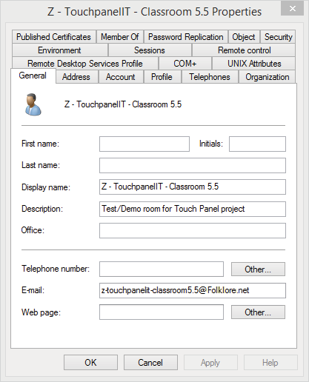

1

2

3

###### Figure 56. E-mail Address Displayed on the General Tab

1. If necessary, click the **General** tab (1). The general properties for the room are displayed.
2. Note the room e-mail address shown (2). This value is the UPN, the value used as the

**only** valid Exchange User ID for this room in the Room Scheduling System.

1. Click **Cancel** to exit the display (3).
2. Repeat steps 3 through 8 for each desired room.

**TIP:**

Write down the UPNs of all rooms for setting up the Room Scheduling

System.

### Verify the Exchange User ID is the UPN (Office 365)

**NOTES:**

* The guidelines in this section are intended for IT professionals only. Installers or integrators attempting to follow these guidelines should do so only in close

coordination with the IT department of the organization where the Room Scheduling System is to be installed.

* This information is correct as of June 2017. However, this site is not controlled by Extron and may change.

Verify the UPN as follows:

1. Access the Office 365 Admin center page (see figure 57).

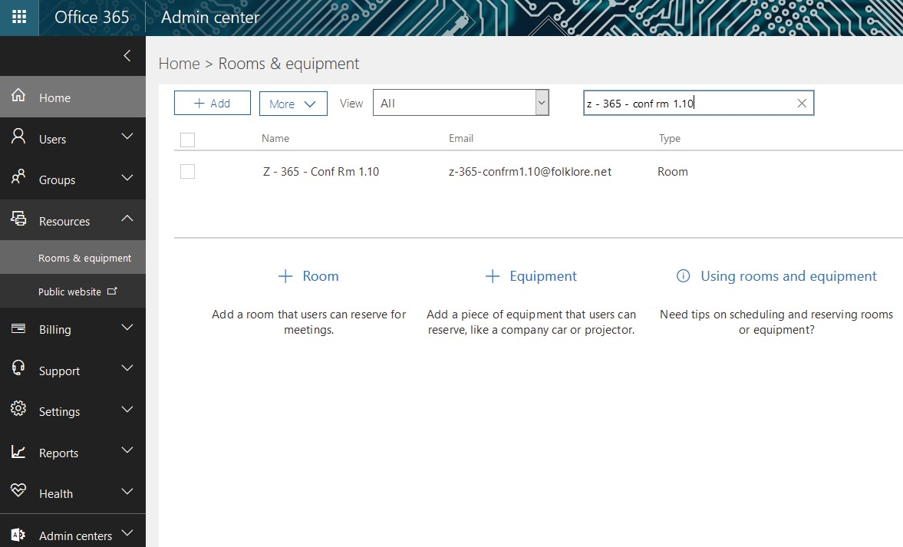

2

3

1

###### Figure 57. Active Directory

1. Click **Resources > Rooms & equipment** (see figure 57, 1). The Home > Rooms & Equipment pane displays.
2. Enter the room name in the Room field (2) and type <**Enter**> on the keyboard. The room information appears (3).
3. Click on the room information (3). The dialog box for the selected room opens (see

**figure 58** on the next page).

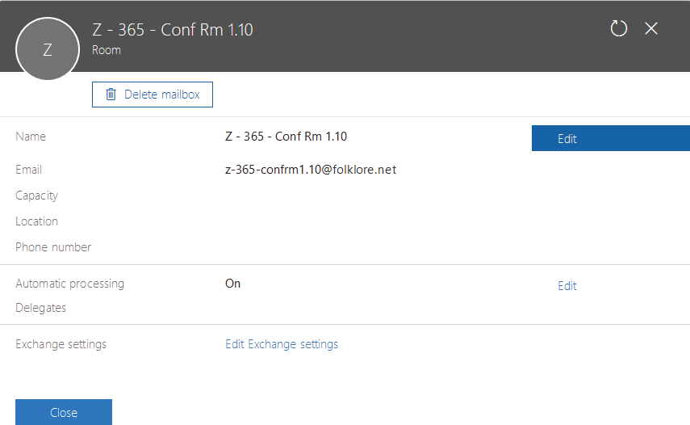

1

2

###### Figure 58. Room Information Dialog Box

1. Note the room e-mail address shown (see figure 58, 1). This value is the UPN, the value used as the **only** valid Exchange User ID for this room in the Room Scheduling System.
2. Click **Close** to exit the display (2).
3. Repeat steps 2 through 6 for each desired room.

**TIP:**

Write down the UPNs of all rooms for setting up the Room Scheduling

System.

## Set up the Room Scheduling System in the Microsoft Environment

Perform the following operations to set up the Room Scheduling System:

* Start the Deposition Scheduler software as an administrator (see **Start the Program** on page 15).
* Discover any panels that are on the same subnet as the computer running Deposition Scheduler software (see **Automatically Discover Panels** on page 16).
* Manually add any panels from a different subnet than the computer that is running Deposition Scheduler software (see **Manually Add Panels** beginning on page 16).
* Perform the following for **each** panel in the system:
  + Connect to the panel (see **Connect to the panel** on page 18).
  + Verify or change settings (internet variables and password) on the **Communication Settings** tab (see **Communication Settings window** on page 19).

**NOTE:** If you change any settings but the **Hostname**, the panel disconnects and you must rediscover or manually find it again. A better approach is to set these values ahead of time using the on-screen menus of the panel (visit [**www.extron.com**](http://www.extron.com/) and see the applicable panel user guides).

* + Verify or change settings (panel appearance, time, and audio clicks) on the

**General Settings** tab (see **General Settings window** on page 20).

* Customize the appearance of your panels as desired. See the following:
* **Layout tab** on page 37
* **Background tab** on page 40
* **Date and Time tab** on page 41
* **Panel Message tab** on page 42
* Select the calendar server, Microsoft Exchange or Microsoft Office 365 (see **Panel****Configuration Tab** on page 21.
  + **If you selected Microsoft Exchange above**, configure the Deposition Scheduler software to connect with the panels through the Exchange server (see **Exchange****configuration** on page 22).

**NOTE: For Microsoft Office 365**, connection is made automatically through the Office 365 server.

* Configure one or more panels (see **Configure panels** on page 23 [for Microsoft Exchange] or **Configure panels** on page 28 [for Microsoft Office 365]).

**NOTES:**

* The two "Configure panels" procedures linked above are identical; you can refer to either.
* The IP Address and Hostname variables are set when you discover or manually add panels.
* The only values that you must enter are the Exchange User ID and the Exchange User Password.
* The **Panel Design** menu includes the **DefaultTLPTemplate**, which is the default that is installed as part of the Deposition Scheduler software, as well as any templates that you have created and saved (see **Templates pane** on page 44).
* Send the configuration to selected panels (see **Send and retrieve the configuration**

on page 35).

